Title: Autonomous Drone Delivery System for Industry 4.0

Author: Jianhui Li

Supervised by: Prof. Jun Yang & Dr. Tengyuan Zhang

Table of Contents

**Introduction3**

**Basic information8**

**Hardware setup9**

**Mobile SDK10**

Run sample application10

**Onboard SDK13**

Run sample application13

How to install raspberry Pi (how to download from Github)15

How to find IP of RPI16

How to use SSH 18

SSH WiFi21

Set static IP address22

how to use VNC connection23

how to use visual studio Linux development 25

code explain26

How to use Linux (basic operation) 52

How to use g++53

Restart with an example by using LED55

how to use ultrasonic sensors on RPI 57

**Setup Raspberry pi4****8**

Download Onboard-SDK Guidance-SDK from github48

WinSCP48

Download libusb-1.0.949

Setup the Guidance-SDK environment on RPI50

Update RPI tools51

Text editor51

**Guidance-SDK**50

Run sample application58

**Conclusion61**

**Video explanation62**

Summer research report

Beginning date: May 7th, 2018

End date: August 24th, 2018

Content of research: Smart drone delivery system

Participator: Bowen Xu & Jianhui Li

Supervisor: Prof. Jun Yang

Introduction:

Physical details about the design:

The drone delivery system includes a robotic arm and drone platform. The robotic arm is controlled by an Arduino board. The drone is controlled by Raspberry Pi. The arm connects the front part of the drone. The battery and guidance system moves to the rare part of the drone to keep the center of gravity in middle of the drone.

The power supply is separated to arm and drone specifically. The onboard controller use the main battery, and decrease the voltage by using a dc-dc convertor. The arm uses a 9-volt dry cell. The power supply system should update in future.

Three views of system show how the arm and drone body connect.

front view:

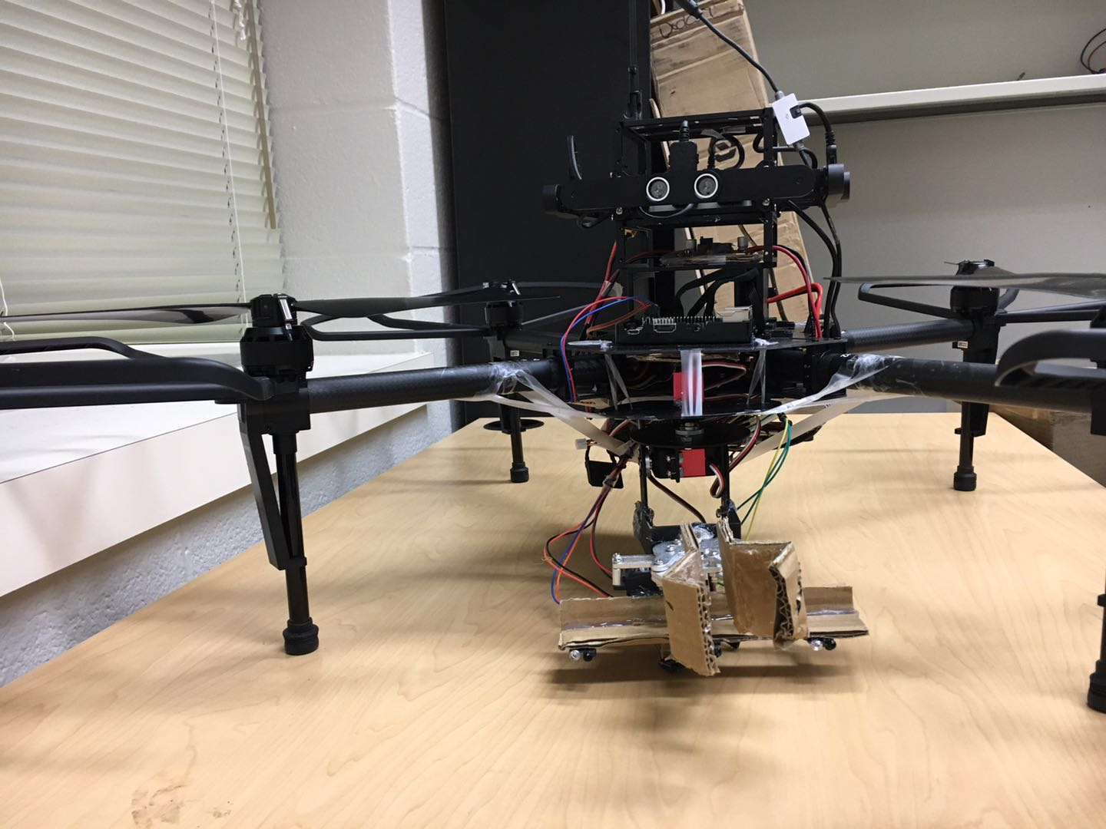

right view:

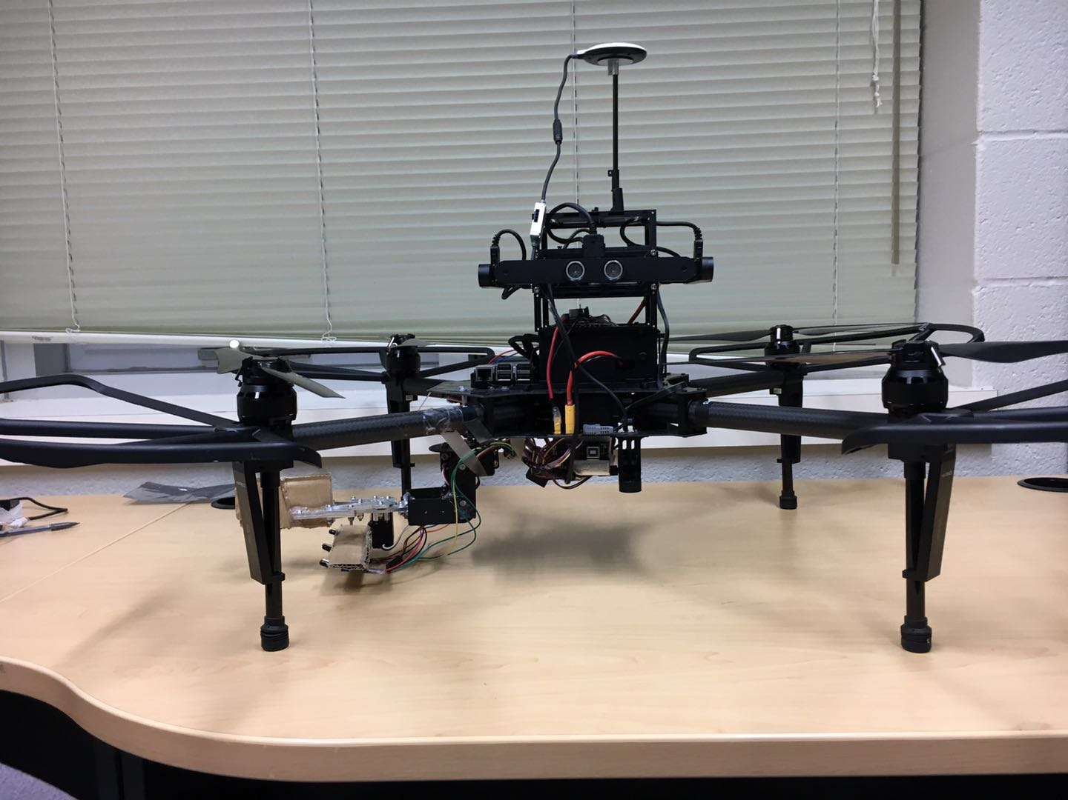

top view:

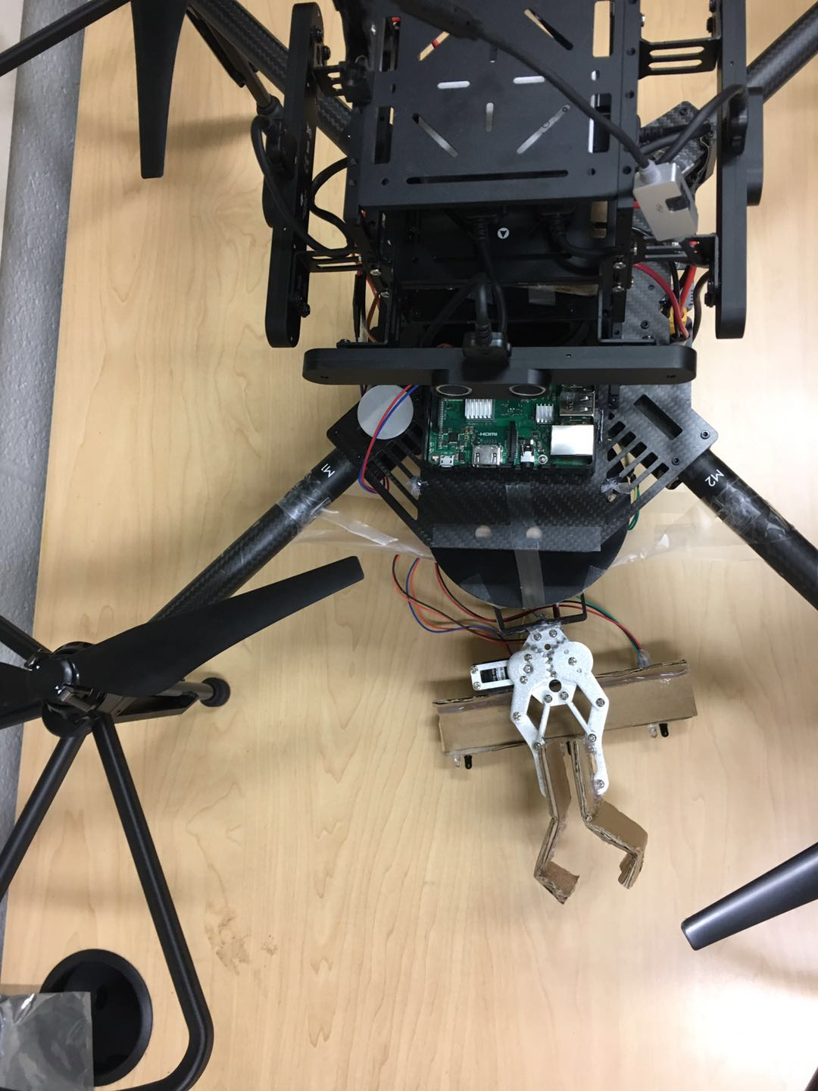

isometric view:

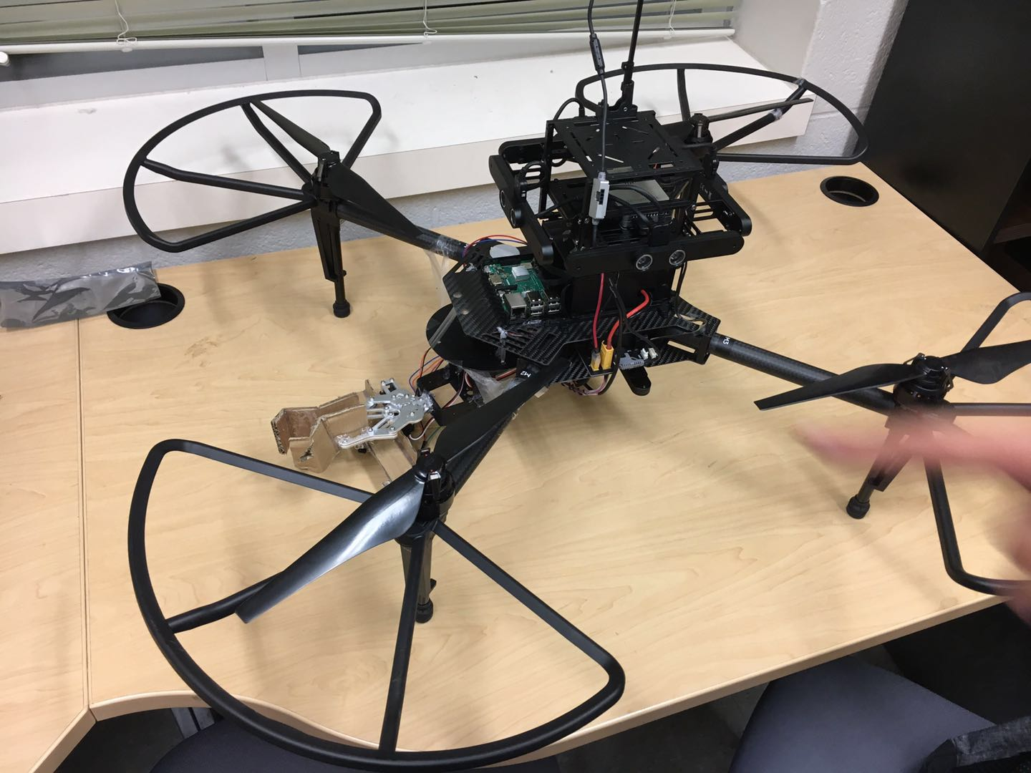

software detail of the smart drone delivery system:

The system can be summarized in three part: Onboard computer, aircraft,

control of the whole system:

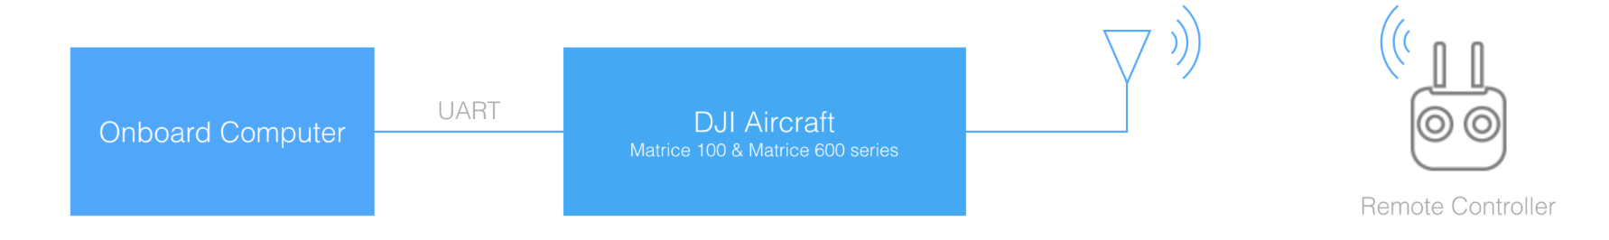

The part of drone:

The onboard computer send data through the UART port. The remote controller just uses to ensure the secure of drone, and deals with emergency. More detail is introduced in previous part.

The part of claw:

The mechanical structure is controlled by Arduino board.

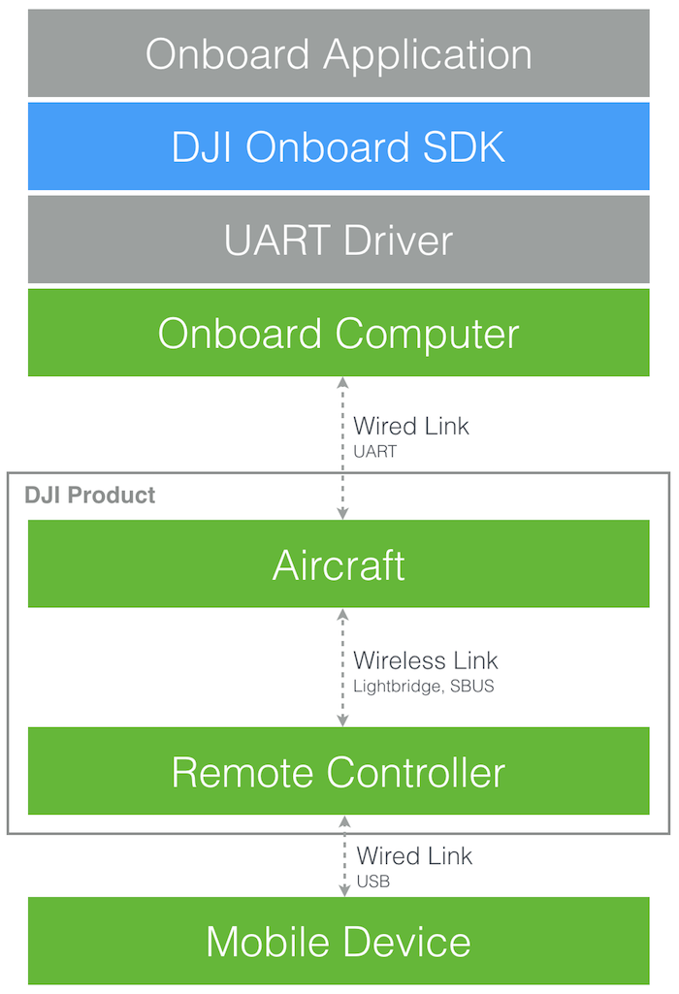

The DJI Onboard SDK is an open source software library that enables computers to communicate directly with a selection of DJI aircraft and flight controllers over a serial interface. The SDK gives access to aircraft telemetry, flight control and other aircraft functions, meaning a developer can use the SDK to attach their own computing device onboard an aircraft and use it to control flight. The SDK includes fully featured ROS wrapper compatible with ROS standards

an aircraft simulator.

In this project, C++ is the main coding language. Raspberry Pi is the best choice based on its function and price. The Raspbian system, one of specialized Linux system, provides all functions needed in this project.

Limitations:

1. The claw needs a very accurate position to get the box. The effective area is too tiny.

2. Indoor fly is too unstable

3. The drone cannot land to an accurate position. The error is within 10 cm

4. The compass error appears when the drone indoor, which will cause the drone not to work

possible solutions:

1. The claw needs to update its structure, power and efficiency.

The claw should meet at least 50 percent successful ratio when testing. And, it needs to tightly connect the main body of drone.

2. The testing place is required at least 6 meters * 6 meters (more than 30 square meters) area.

3. The guidance system works well when flying above zebra crossing carpet. Therefore, if allowed, the testing lab needs to decorate with the texture carpet.

4. There is no method to solve this trouble. The developers can calibrate the compass outdoor or change to another place.

INFORMATION of all device:

1. Basic information of RPI:

raspberry pi IP:

eth0: 192.168.137.99

wlan0:192.168.191.3

raspberry pi user name: pi

raspberry pi password: raspberry

1. Highly recommend using a Windows system to do all the work. Because, MacOS does not allow to share a public network to another device, which mean you cannot share
2. For Guidance system, do not plug out the VBUS 2 port in the right-side sensor, which has a damage in the port.

Concept (knowledge):

cmake &cmakelist: <https://cmake.org/cmake-tutorial/>

make & makefile: <https://www.gnu.org/software/make/manual/make.html>

Hardware setup:

1. dc-dc converter LM2596 DC-DC

|  |  |
| --- | --- |
| Regulator Type: | Step Down ( Non Isolated input to Output ) |
| Input Voltage: | +4 to 40vdc |
| Output Voltage: | +1.25 to 35vdc |

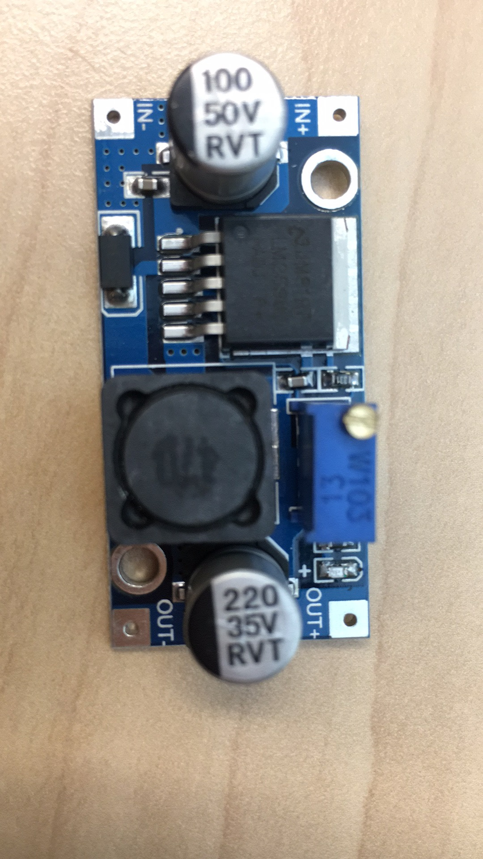

Step down means the output voltage can only decrease from the input voltage. The voltage converter uses for suppling power for RPI. The input wiring connects to xt30.

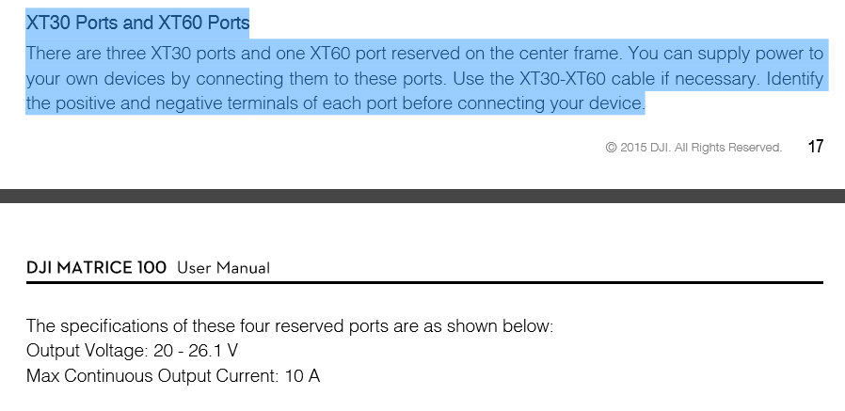

According to Matrice 100 user manual, the output voltage is about 20-26 volts. Therefore, you need to use a multimeter to test the output voltage and adjust the knob. The RPI working voltage is about 5V.

2. raspberry pi status LED light

1.1 When the PWR led turns on, which the power is about 5v and power connected. If the PWR led turns off, which means the power is below 5v. And then, you need to check if the dc-dc converter works well.

If the ACT light always turn on, SD card may have some problem. The ACT light should blink when reboot, then turn off.

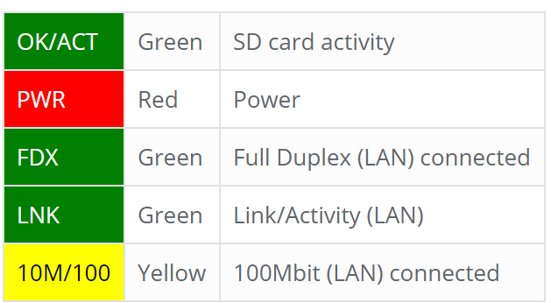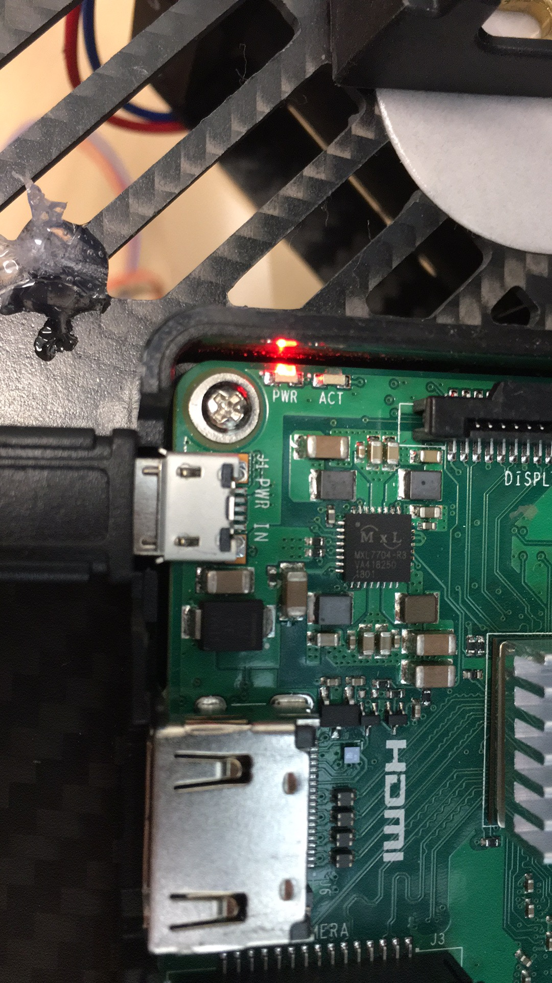

3. The input port of converter connects to xt30, other side connects to RPI (5v and GND)

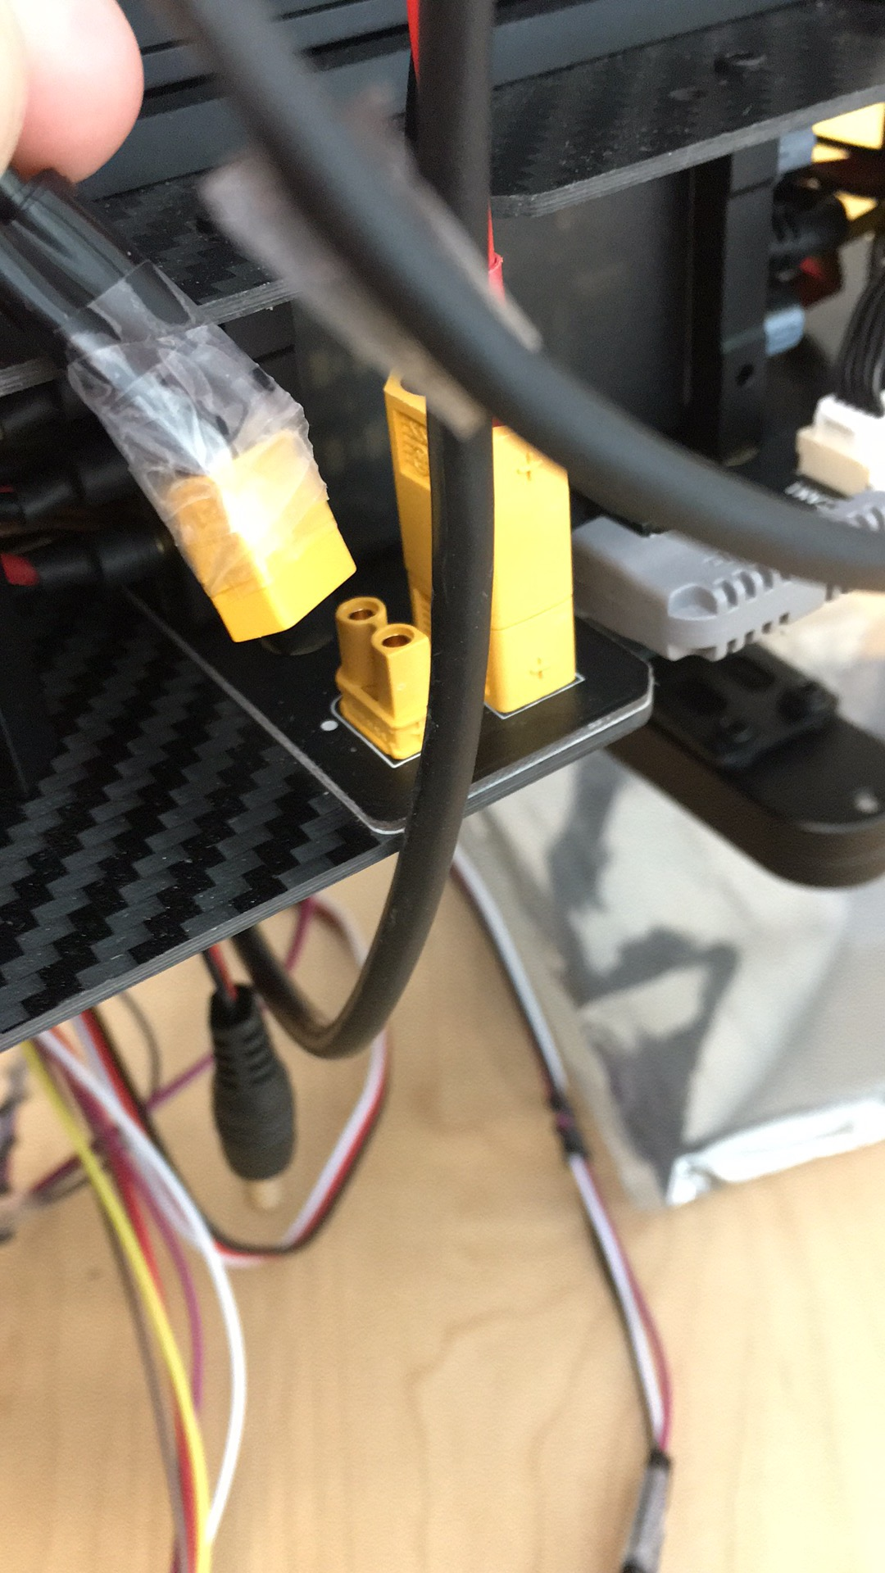 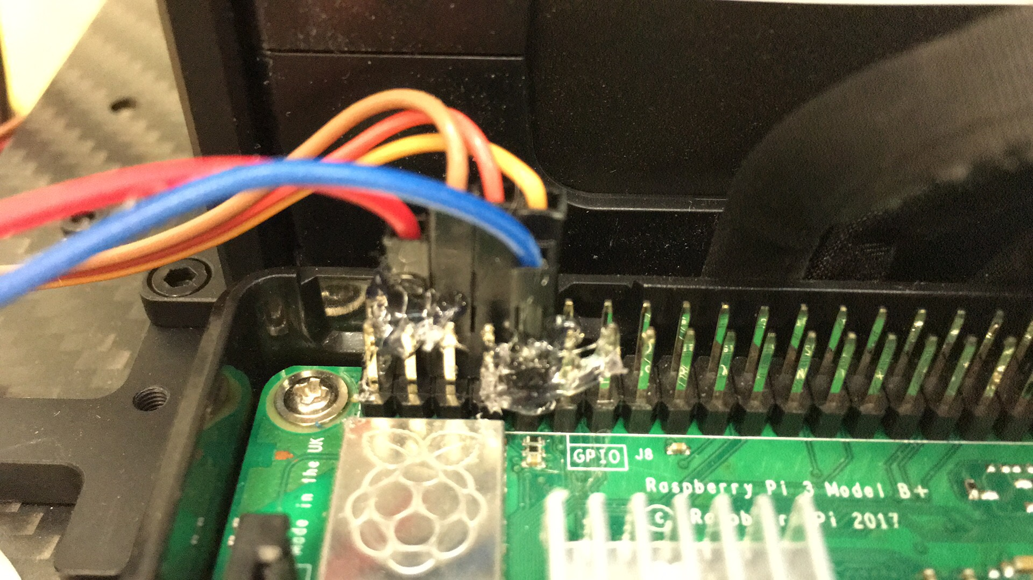

4 parallel install.

The first kind is 1345s Quick Release Props.

The second kind is 1345t.

1345s is the original parallel. Right now, the parallel is using 1345t. 1345s and 1345t have different adapter.

1345s 1345t

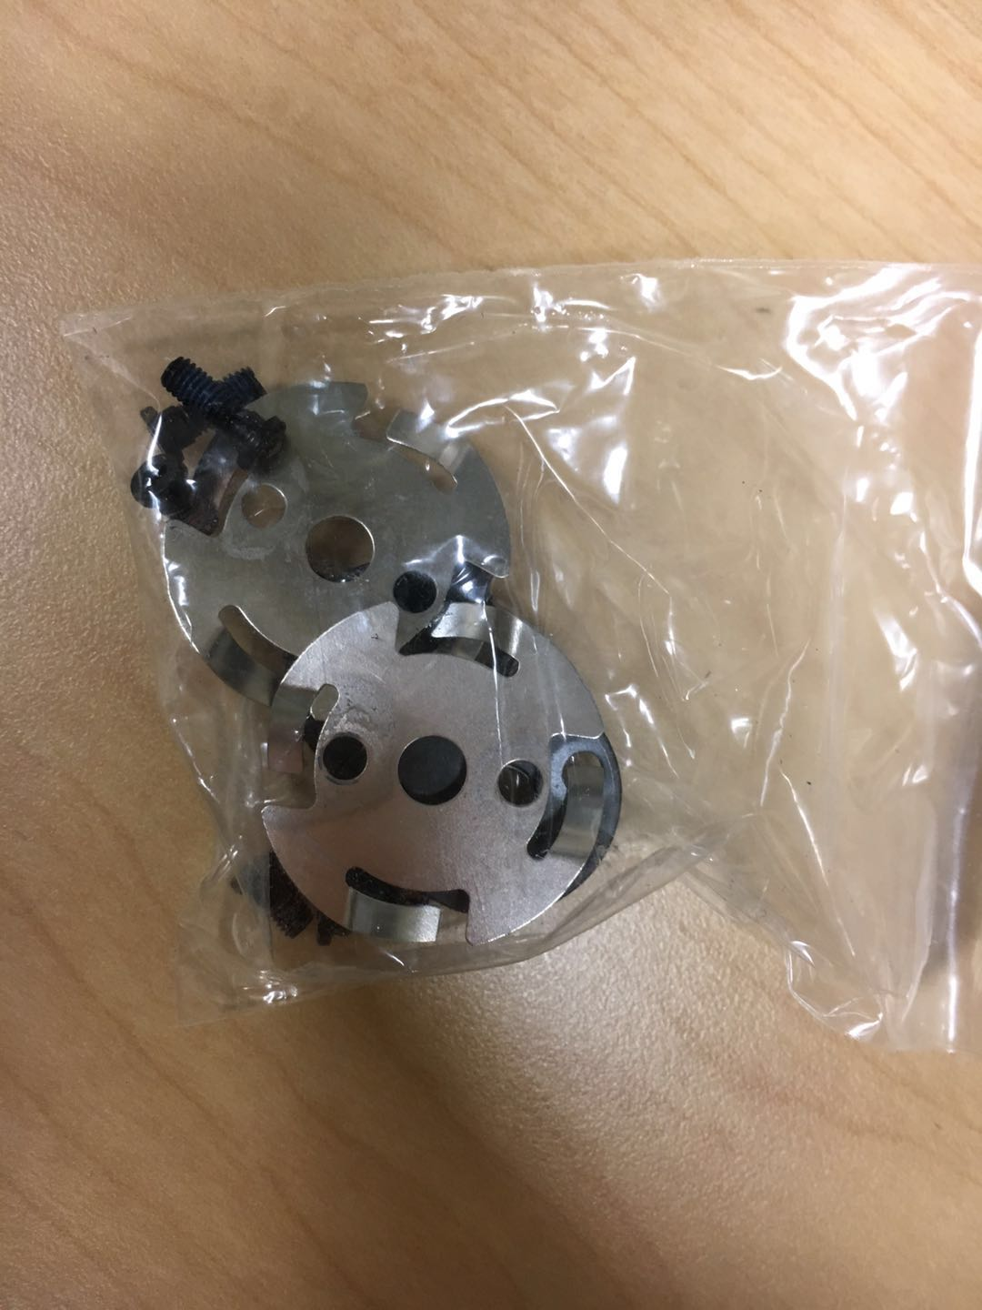 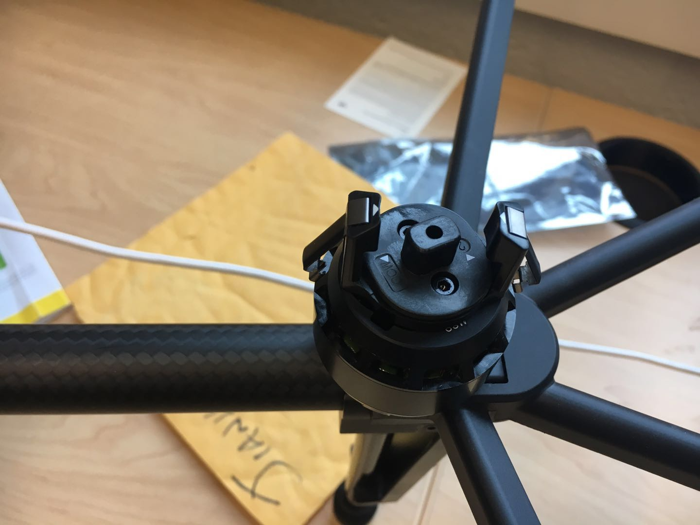

more detail please search the youtube guide:

<https://www.youtube.com/watch?v=bBLBeczT170>

<https://www.youtube.com/watch?v=d_-4uaY1kYU>

Mobile-SDK:

Mobile-SDK means the user can use mobile app to control the drone. It supports Android and IOS platform. It can communicate with Onboard-SDK, can control the fly attitude like using remote controller and can get the roll, pitch, throttle and other information from the drone. In the report, a sample of IOS will be explained in detail.

If you use IOS platform, I recommend using Object-C language, because Object-C has more resource to learn and DJI gives more details.

In DJI official website, <https://developer.dji.com/mobile-sdk/documentation/quick-start/index.html>, which gives steps how to test a sample. Please follow all the step, and I will give more detail about some steps

Sample application

Register as a DJI Developer

Generate an App Key

Every application needs a unique App Key to initialize the SDK.

To create an App Key for an application:

Go to the DJI developer [User Center](http://developer.dji.com/en/user/apps)

* Select the "Apps" tab on the left.
* Select the "Create App" button on the right.
* Enter the name, platform, package identifier, category and description of the application.
  + For iOS, the package identifier is the [Bundle Identifier](http://developer.dji.com/en/user/mobile-sdk/ios-configuration).
  + For Android, the package identifier is the [Package Name](http://developer.dji.com/en/user/mobile-sdk/android-configuration/).
* An application activation email will be sent to complete App Key generation.
* The App Key will appear in the user center, and can be copied and pasted into the application.

Notice: the bundle identifier: after you write the product name and organization identifier, the xcode will generate a bundle identifier for you.

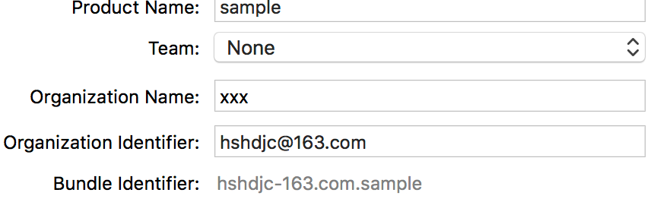

iOS Sample App

iOS Sample Code Setup

Objective C App Key Setup

Navigate to the **ObjcSampleCode** folder and open the **DJISdkDemo.xcworkspace** project in Xcode.

* Change the [Bundle Identifier](http://developer.dji.com/en/user/mobile-sdk/ios-configuration) to a unique identifier and use it to generate an [App Key](https://developer.dji.com/mobile-sdk/documentation/quick-start/index.html#generate-an-app-key).
* Paste the generated App Key string into the DJISDKAppKey string value of the **info.plist** file of the Xcode project:

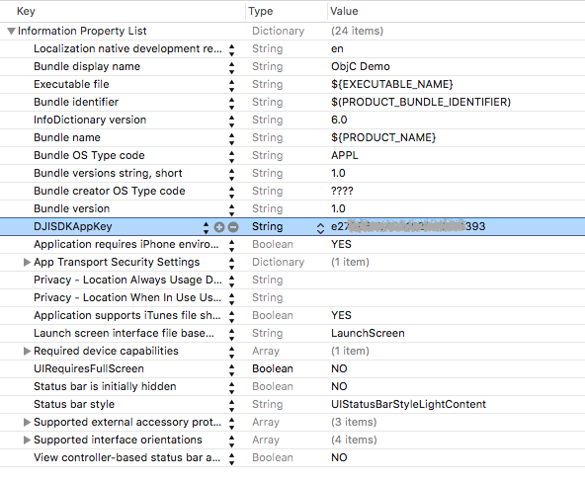

Resource: <https://developer.dji.com/mobile-sdk/documentation/quick-start/index.html>

Onboard-SDK

Notice:

In this report, there are some short names needed to clarify: raspberry pi is shorted as RPI.

Matrice 100 Series is M100;

Sample application:

1.1 In RPI, go into the Onboard-SDK

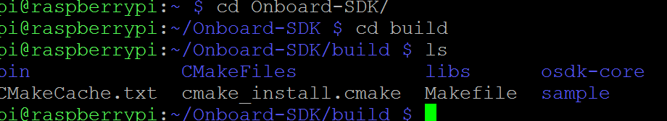

mkdir build && cd build  
cmake ..   
make djiosdk-linux-samples  
cd bin

notice: cmake .. means you go to the last level document(Onboard-SDK), then cmake will invoke the CMakeFile.

Then you will see in build file:



If you just use command: make

It will make all samples in bin file:

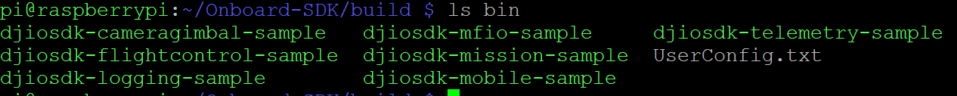

1.2 Run the sample app

1.1 You have entered the sudo usermod -a -G dialout $USER command, then logged out and logged back in to your account (you don’t have to need to do it)

1.2 Vehicle/Flight controller is in simulation mode, connected via USB cable to a computer running DJI Assistant 2. Or you can in DJI Go app, change to simulation mode,

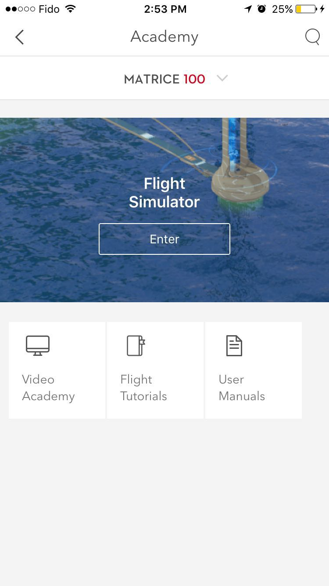

1.3 Enable API Control is checked on DJI Assistant 2's SDK page

1.4 The baudrate on DJI Assistant 2 matches that in your UserConfig.txt file

We use 230400, which should be same as the value in Assistant 2

In developer center-🡪 create app-🡪 Onboard-SDK

App ID and Key have been entered in your UserConfig.txt file.

app_id : 1057912

app_key : e0c989eebdb95a618a12e4b88c6e59e618d568ffd12857928ba915d51d7c431d

device : /dev/ttyS0

baudrate : 230400

Notice: in RPI 3B+/3B the device --🡪 /dev/ttyS0

In RPI 2B the device ---🡪 /dev/ttyAMA0

1.4 Your hardware setup matches that in the Hardware Setup guide

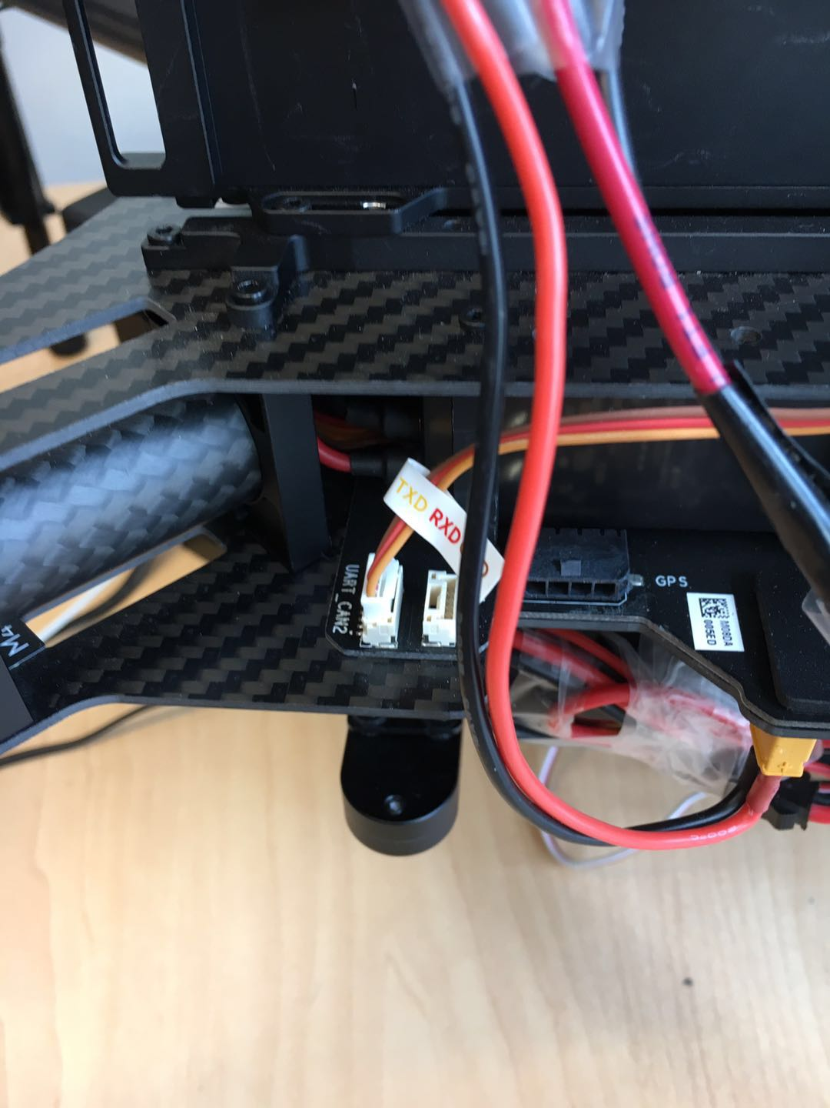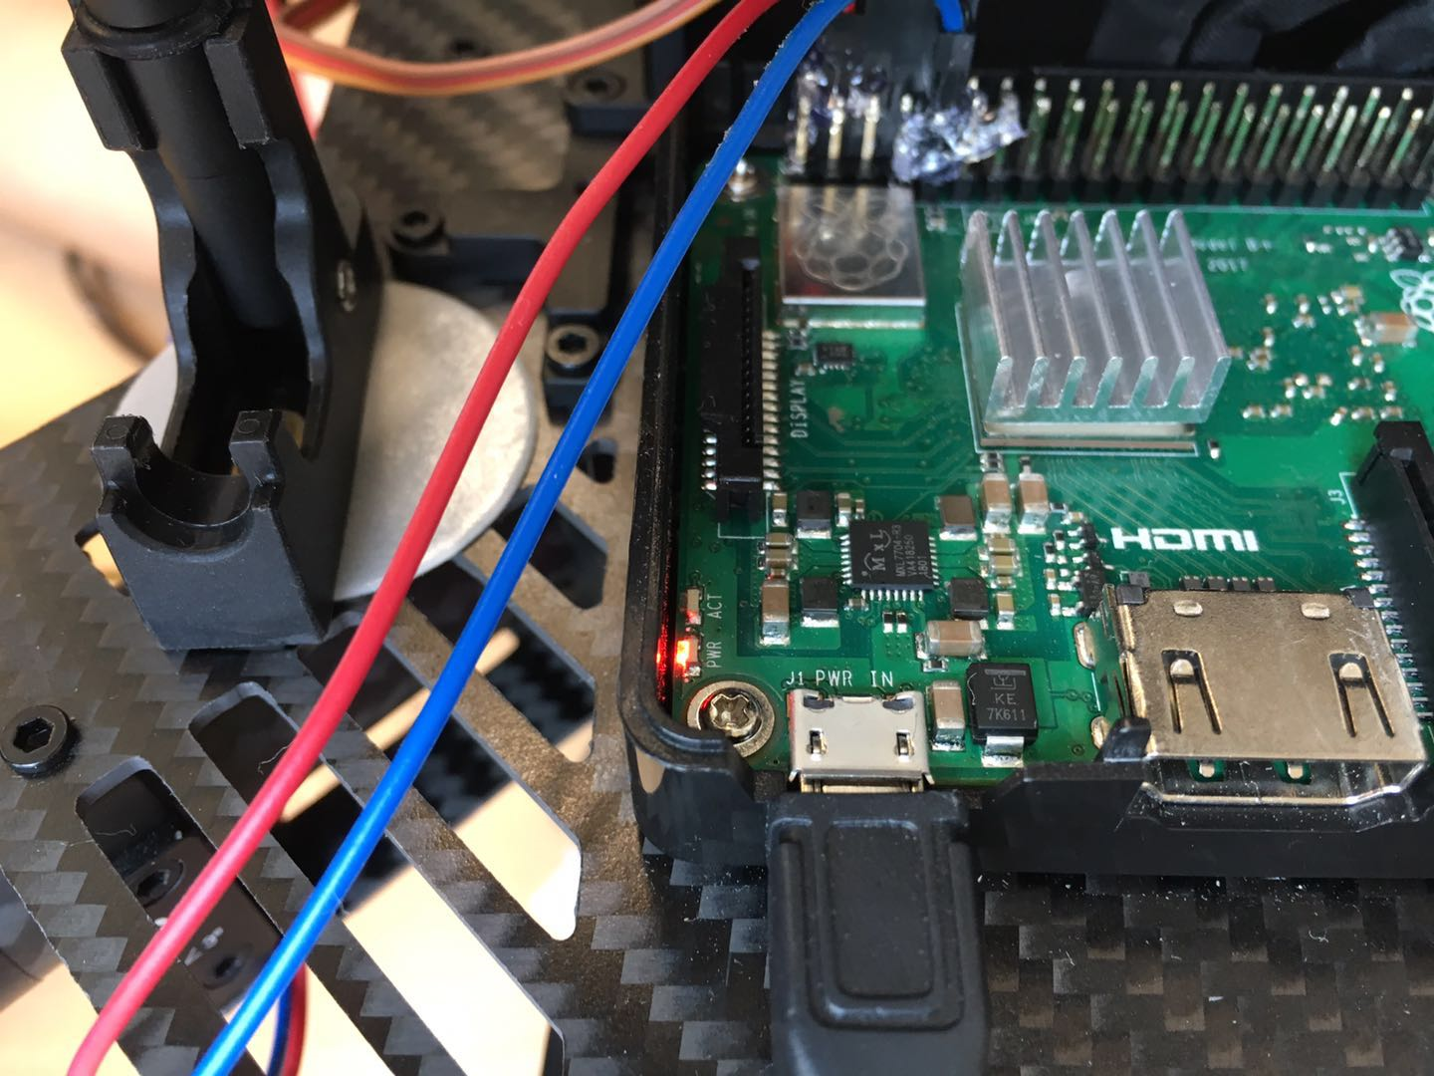

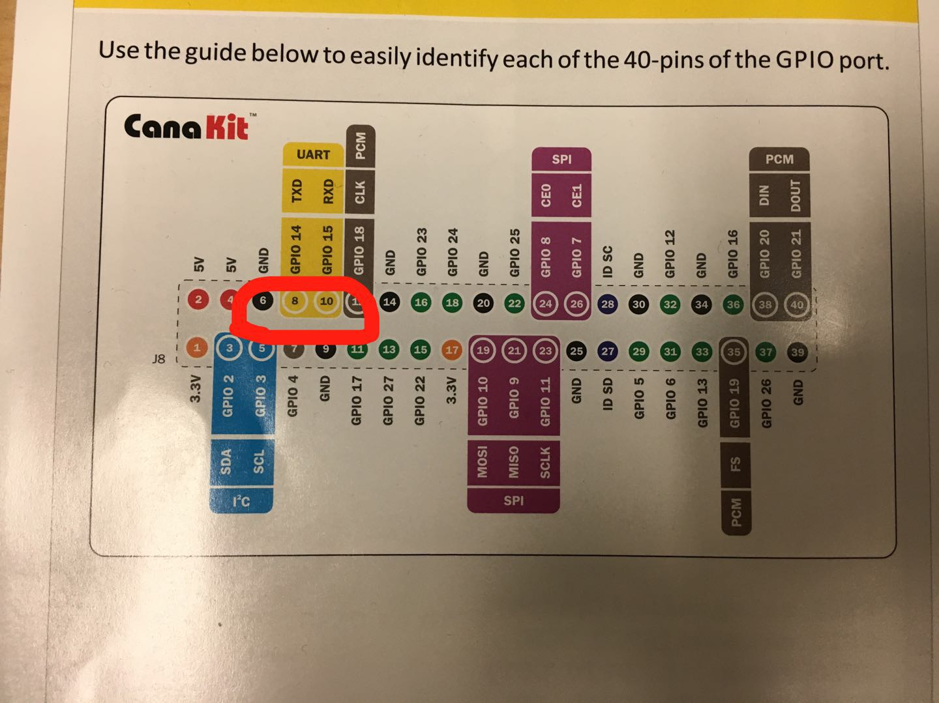

Connect the RX to drone’s TX, and TX to drone’s RX, GND to GND.

1.5 modify the cmdline file in RPI’s console.

sudo nano /boot/cmdline.txt

dwc_otg.lpm_enable=0 console=ttyAMA0,115200 kgdboc=ttyAMA0,115200 console=tty1 root=/dev/mmcblk0p2 rootfstype=ext4 elevator=deadline rootwait

change into :

dwc_otg.lpm_enable=0 console=tty1 root=/dev/mmcblk0p2 rootfstype=ext4 elevator=deadline rootwait

1.6 If all of these are done, proceed to enter the next set of commands inside the /Onboard-SDK/build/bin directory:

./djiosdk-flightcontrol-sample ../../sample/linux/common/UserConfig.txt

Resource:

<https://developer.dji.com/onboard-sdk/documentation/quick-start/quick-start.html>

1. how to download and install a Linux system in Raspberry Pi:

* 1. go to Raspberry Pi official website: click download button.
  2. website link: <https://www.raspberrypi.org/downloads/raspbian/>
  3. 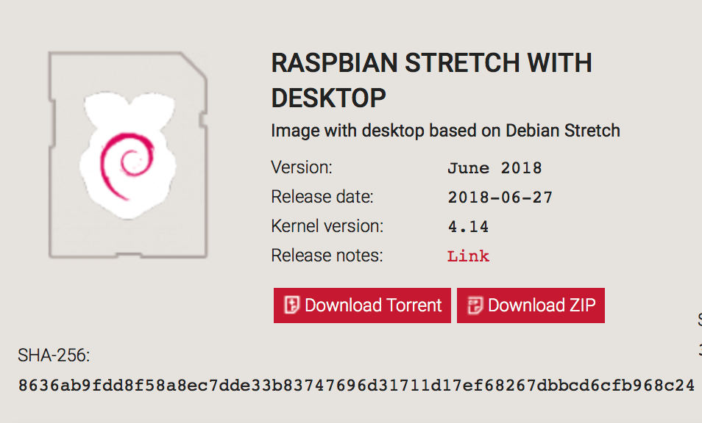highly recommend Raspbian with Desktop, which is convenient for new learner
  4. Download the Windows installer from <https://etcher.io>
  5. Run Etcher and select the unzipped Raspbian image file
  6. Select the SD card drive
  7. Finally, click **Burn** to write the Raspbian image to the SD card
  8. You'll see a progress bar. Once complete, the utility will automatically unmount the SD card so it's safe to remove it from your computer.
  9. It will take you about 20 minutes. And, there are also 10 minutes for verification.

Notification: The SD card is ready to use, and you can also use SSH to connect it very easily. If the new SD card is needed, please use SD card recommend for RPI, NOTICE, not all SD card can be used for RPI. A low speed SD card may affect the operation speed of RPI. Besides, do not format SD card.

Recourse:

need more information and doubt, please check: <https://www.raspberrypi.org/documentation/installation/installing-images/windows.md>

2. how to find the IP address

1.1 win+R to open run, and use cmd

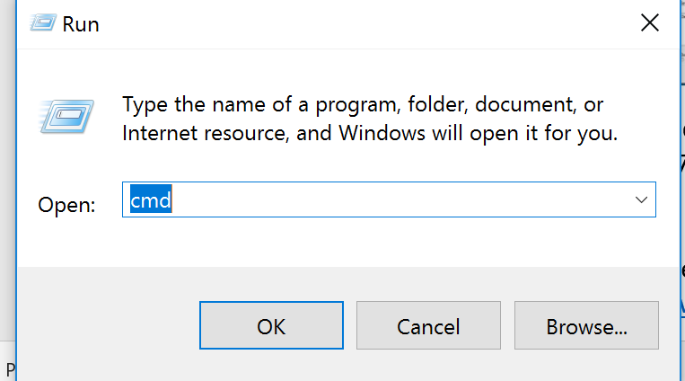

1.2 use arp -a in the command line. arp -a is a tool to find the IP address of raspberry pi.

1.3 before the previous two steps, please make sure you have set sharing network.

1.4 In Windows(highly recommend), open the Network and sharing center

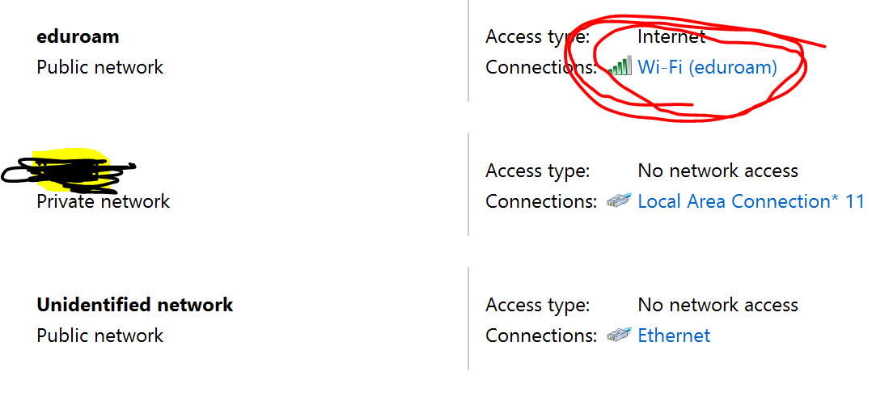

1.5 In the first Public network, right click WI-FI ---🡪 properties ----🡪 sharing ----🡪 check the first box

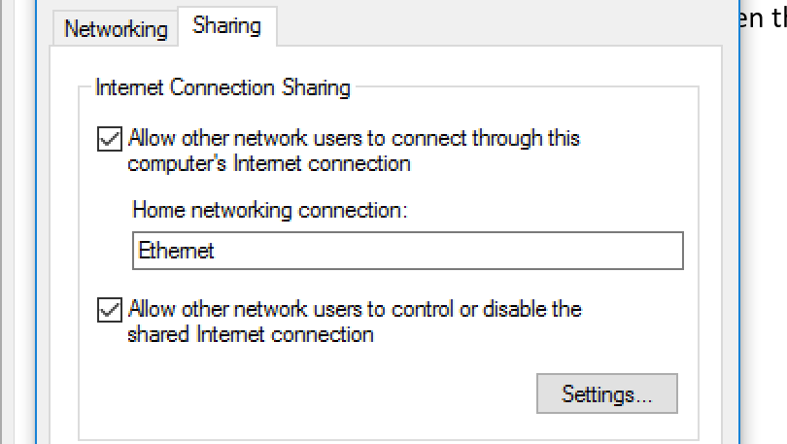

* 1. If you can see the home networking connection choice, choose ethernet at first.
  2. Then go back to cdm.exe. Use arp -a (just copy it).
  3. You will see similar result

[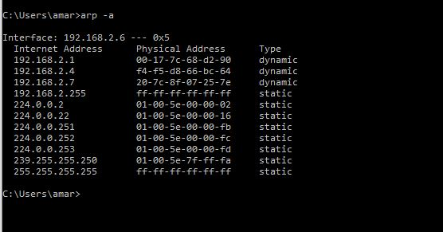](https://www.google.ca/url?sa=i&rct=j&q=&esrc=s&source=images&cd=&cad=rja&uact=8&ved=2ahUKEwjcp7Sllu3cAhWiV98KHXcKAZAQjRx6BAgBEAU&url=https://fossbytes.com/know-everything-arp-address-resolution-protocol/&psig=AOvVaw0_izMeWHKEmvIt51Y34PIm&ust=1534357772690803)

Notification:

1. The general interface would be: 192.168.137.1 --- 0xd. If so, the RPI’s IP should be 192.168.137.xxx. (xxx is between 0-254)
2. Using ping to check if the IP belongs to the RPI. For example,

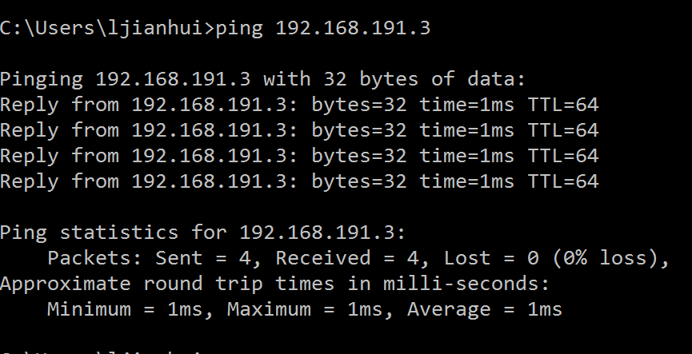

If you see such a result, the IP is right address. Meanwhile, you can see the ethernet port, an orange light blink rhythmically.

Demonstration:

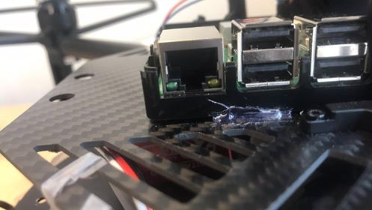

3. if you cannot find out the IP for RPI, restart your computer, then reopen the sharing and network, reboot RPI, then connect the ethernet cable again.

4. know the definition of MAC address (physical address). MAC addresses are useful for network diagnosis because they never change, as opposed to a dynamic IP address, which can change from time to time.

One of MAC address of Raspberry pi is b8-27-eb-18-fb-04. If the computer is using the dynamic ip, mac address may be a method to help you find the right address for RPI.

Resource:

<https://howtoraspberrypi.com/ssh-raspberry-pi-remote-control/>

3. How to use SSH servers and Install SSH to remotly control of your Raspberry Pi

Introduction: what is ssh, and why we need ssh. In this report, we use…

There are many methods to remotely control RPI from your laptop. We choose to let computer to share an IP address to the RPI. Or, you can use a router to connect computer and RPI, and then use your computer to check the IP address of RPI in router.

Step:

1.1 Insert the SD card, connect the card with computer. The SD card should be the one after installing images that is after step 1

1.2 SSH can be enabled by placing a file named ssh without any extension.

1.3 In the boot (G:), 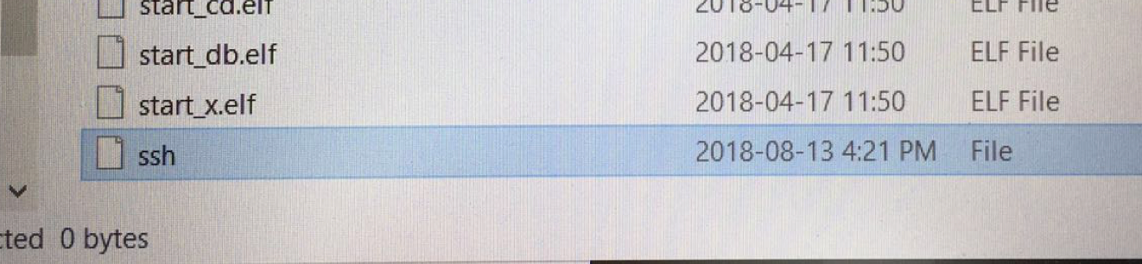

1.4 If nothing wrong, SSH should success, go to the next step, using Putty to connect RPI.

1.5 download PUTTY from the link: [/www.putty.org/](https://www.putty.org/)

1.6

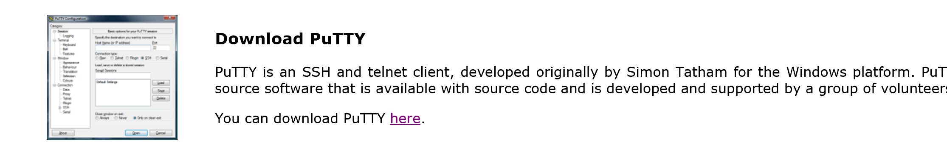

Click here, we only need this version.

1.7 In this raspberry 3B+. The IP address is set as static IP. The eth0 IP is 192.168.137.99

And wlan0 (wifi) is 192.168.191.3

Username: pi

Password: raspberry

Notification:

1. The IP address can be found by using arp -a. In our RPI, the 64GB SD card is set as static IP. The 16GB SD card still need to connect to Ethernet and check the IP address by arp -a. It is critical to know that the static IP is suitable to our own laptop. More information, please check how to set static IP.

2. For the static IP, it may not be showed by using arp -a. You can use ping 192.168.191.3 to check the status.

3. For the WIFI SSH, you need to do a complicated step to set the WIFI. The instruction is showed in the next part.

Recourse:

need more information and doubt, please check:

<https://www.raspberrypi.org/documentation/remote-access/ssh/>

4. How to use SSH by WiFi

There are two methods to connect the mobile-hotspot of your laptop

The first is download a liebao wifi from <http://wifi.liebao.cn/>. However, there is only Chinese version provided. Or, you can use mobile hotspot in windows 10.

1.1 go to setting -🡪mobile hotspot -🡪 turn on it. Username and password

1.2 set your own username and password

1.3 In RPI, use sudo nano /etc/wpa_supplicant/wpa_supplicant.conf

1.4 in the file, modify it, and add the commend line below:

ctrl_interface=DIR=/var/run/wpa_supplicant GROUP=netdev

update_config=1

country=CA

network={

ssid="jianhui"

psk="jianhui123"

}

The content after ssid is username. Psk is your password.

1.5 sudo reboot, restart your RPI

Notification:

1. sudo iwlist wlan0 scan is for RPI to search the wifi spot nearby. if you cannot connect to the wifi, use this command to search.

2. Or, after you have connected to RPI from laptop by an ethernet cable. Use

sudo raspi-config

go to 2.network option

to wifi setting

after that, you will see your wpa_supplicant document change into something like below.

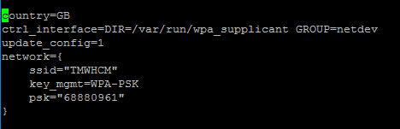

2. after ssid and psk, you can also use priority= 1; and priority =2; to set the different priority. This can help you to connect to more than one wifi.

2.1 second method is to change both interfaces and wpa_supplicant.conf

2.2 sudo nano /etc/network/interfaces

insert

iface wlan0 inet manual

wpa_roam /etc/wpa_supplicant/wpa_supplicant.conf

2.3 then modify the wpa_supplicant.conf according to method 1

2.4 sudo ifup wlan0 (connect to the wifi)

sudo ifdown wlan0 (cut down the connection)

Resource:

<https://www.raspberrypi.org/documentation/configuration/wireless/wireless-cli.md>

<https://lb.raspberrypi.org/forums/viewtopic.php?t=112027>

5. how to set a static IP for RPI

Introduction:

The IP address may change everytime if you do not set a static IP, which takes much trouble when do this project.

1.1 sudo nano /etc/dhcpcd.conf

1.2 insert the content

interface eth0

static ip_address=192.168.137.99/24

static routers=192.168.137.1

static domain_name_servers=192.168.137.1

interface wlan0

static ip_address=192.168.191.3

static routers=192.168.191.1

static domain_name_servers=192.168.191.1

1.3 sudo reboot

Notification:

1. I do not recommend using interface to set the static IP. This method is better to use for RPI 3B+, according to google.

2. the static routers is based on your laptop. If your laptop provides interface is 192.168.151.1, then you need to change your static routers as 192.168.151.1

3. using arp -a in cmd.exe to find a suitable IP address.

4. do not change the IP address same as the one laptop automatically assigned.

Resource:

<https://www.modmypi.com/blog/how-to-give-your-raspberry-pi-a-static-ip-address-update>

6. how to open VNC server to show RPI’s desktop

1.1 In RPI (putty SSH)

sudo apt-get update

sudo apt-get install tightvncserver

tightvncserver

1.2 after tightvncserver, you need to set password for vnc server

1.3 download the client from <https://www.tightvnc.com/download.php>

1.4 in the client, don’t forget add :1 after the IP address

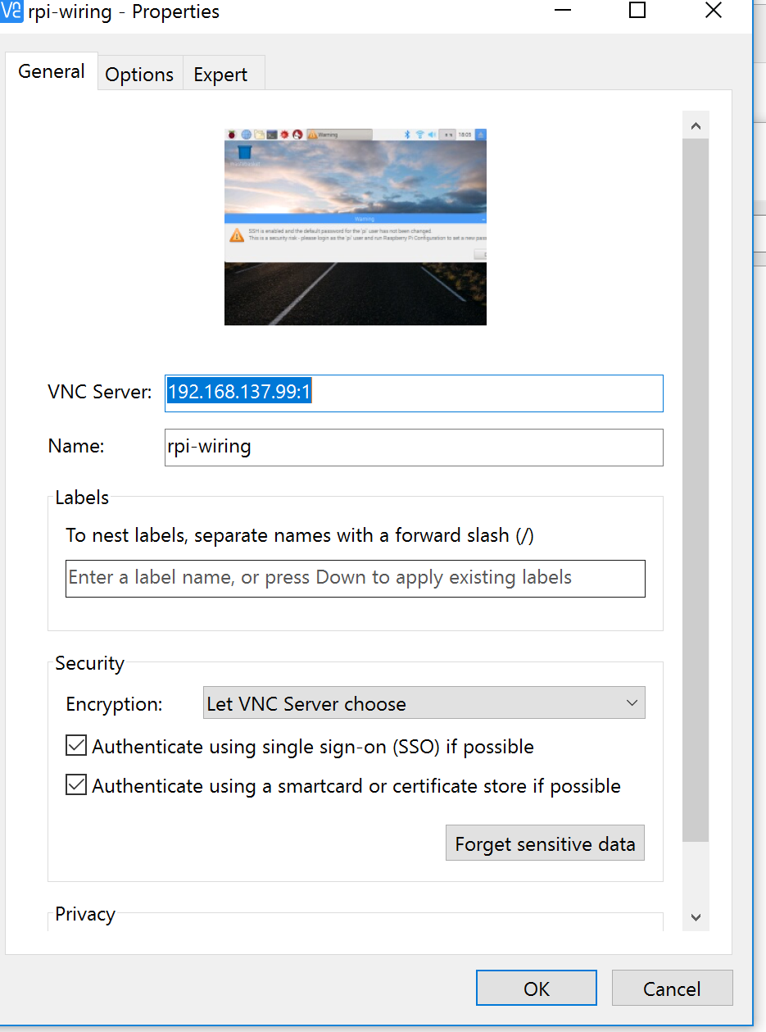Notification:

1. open vncserver manually:

IN RPI: tightvncserver :1

Or : tightvncserver – geometry 800*600:1

2. end vncserver

Tightvncserver -kill:1

3. new :x is :1

Resource:

<https://www.raspberrypi.org/documentation/remote-access/vnc/>

7. visual studio linux development setup

1. install and download linux development with c++

The detail includes in the website below:

Resource:

<https://blogs.msdn.microsoft.com/vcblog/2017/04/11/linux-development-with-c-in-visual-studio/>

<https://blogs.msdn.microsoft.com/vcblog/2016/03/30/visual-c-for-linux-development/>

2. setup

2.1 Build a linux project

2.2 tools-🡪 options-🡪cross platform-🡪add-🡪 add the thing as picture below

Password is same as how you connect ssh by putty (raspberry)

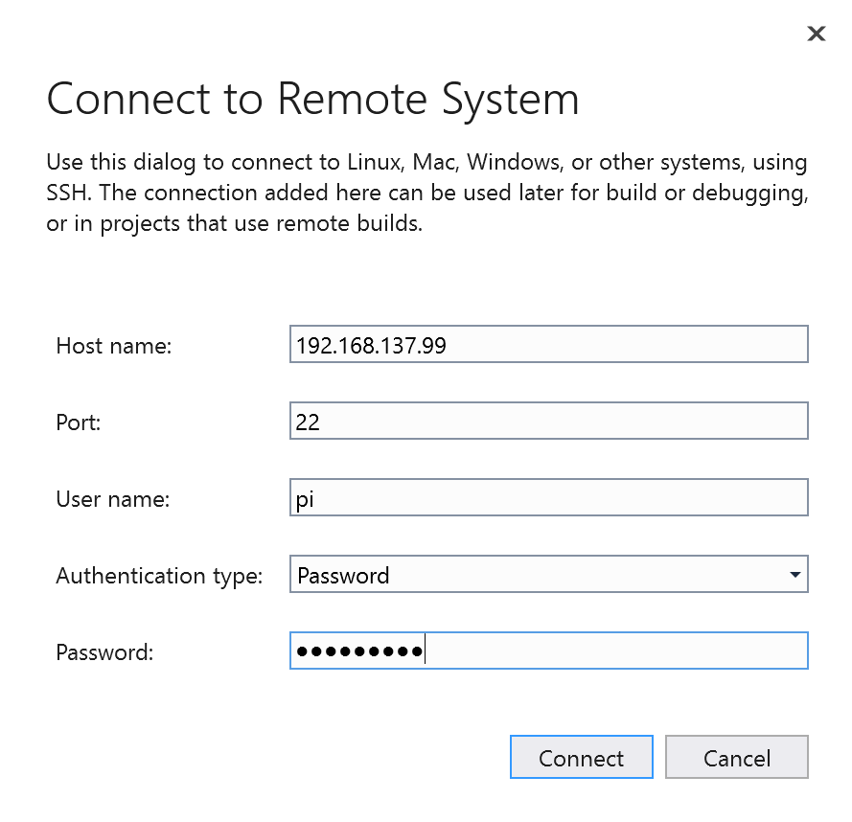2.3 right click your project-🡪properties

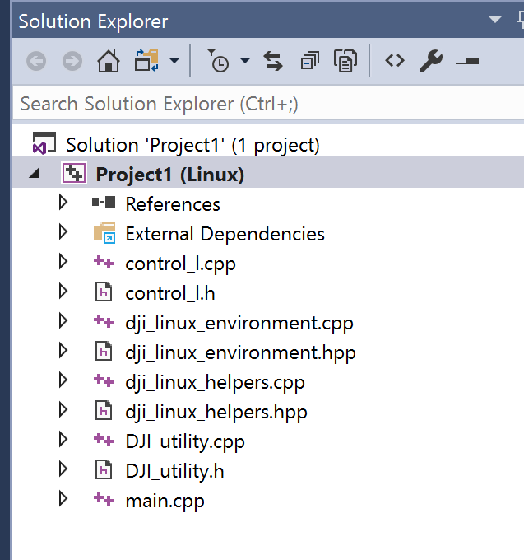

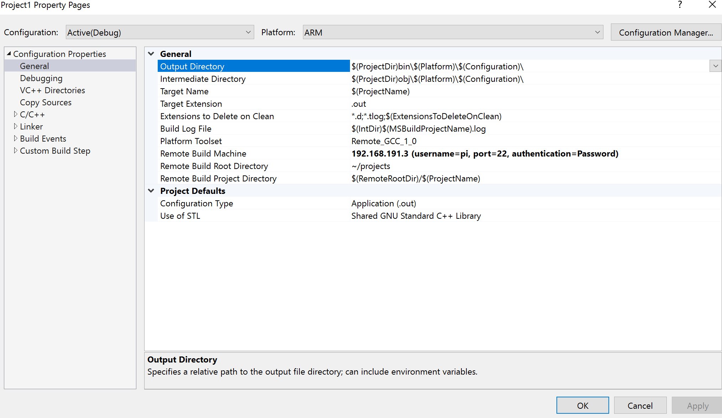

2.4 general-🡪Remote Build Machine-🡪choose the IP address you need for the project. The IP is your raspberry pi’s address

2.5 Debugging Mode: change into the gdb, if it doesn’t work change into the gdbserver

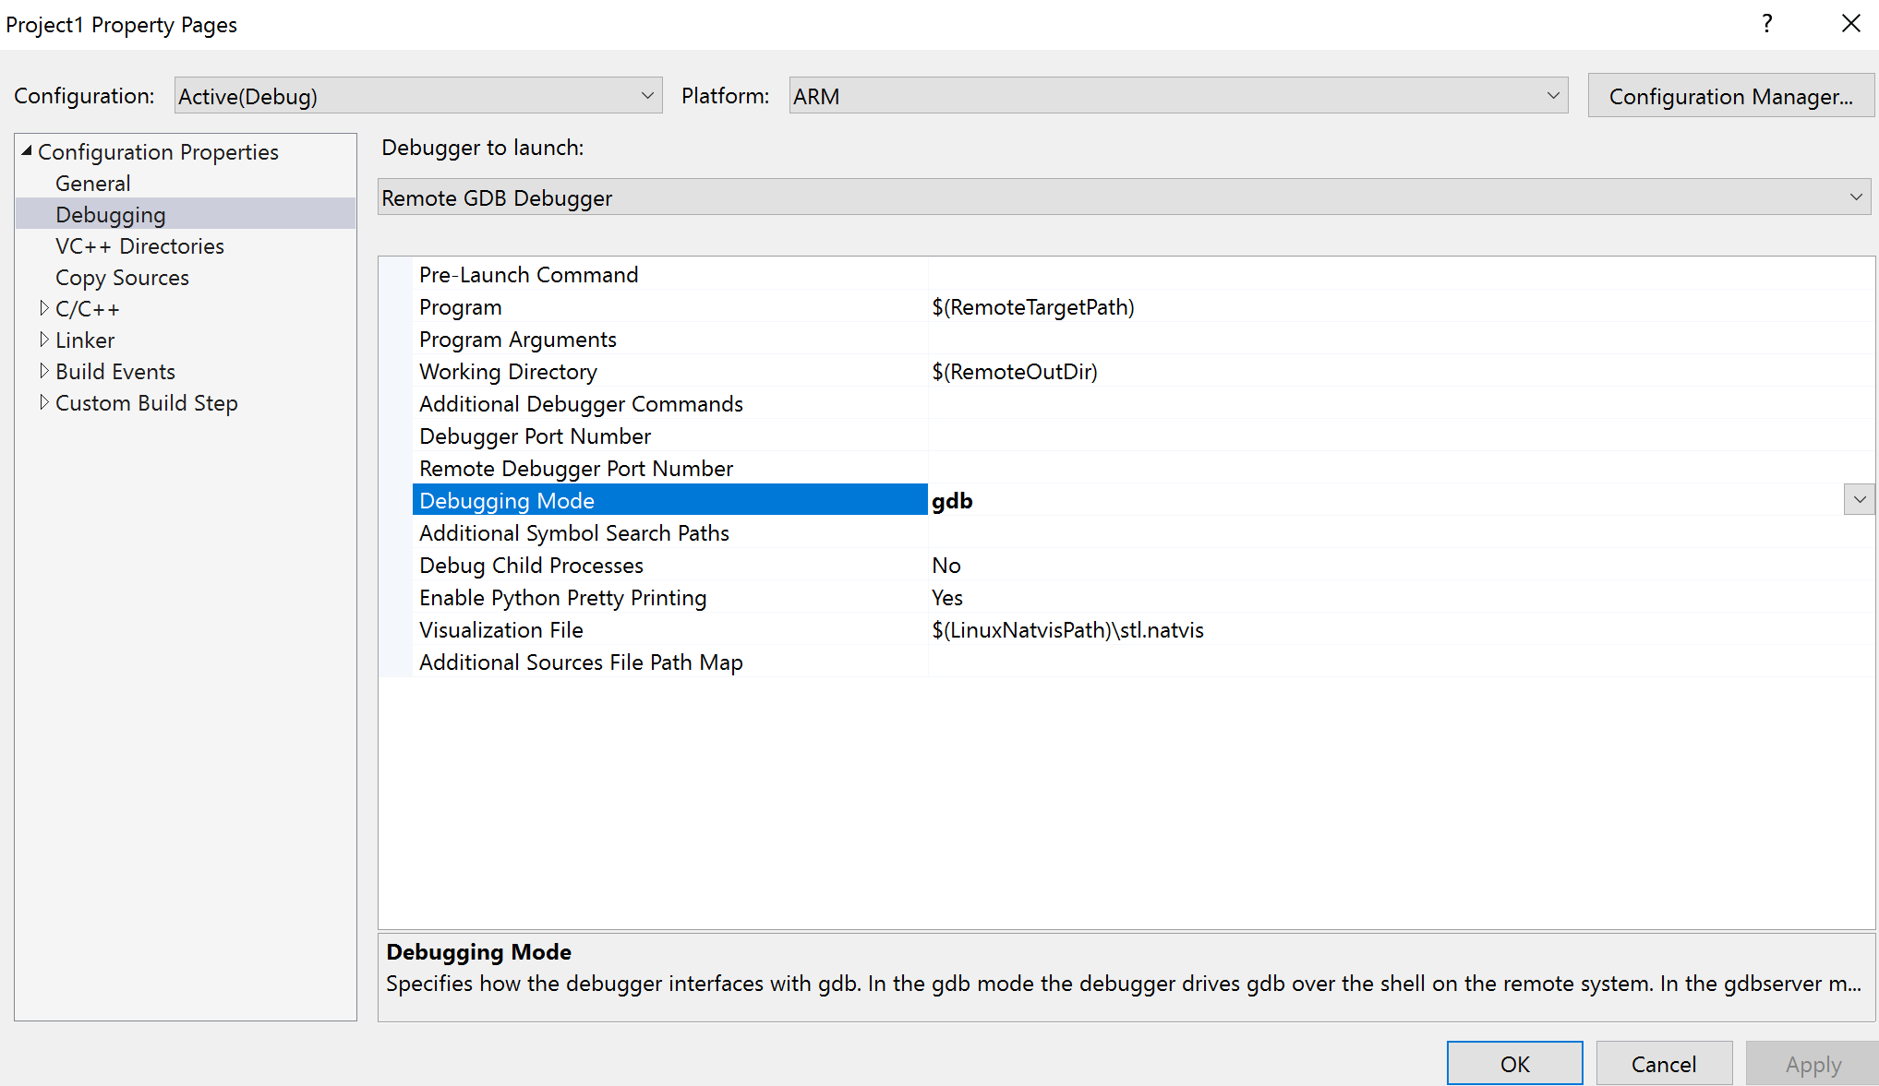

2.6 in the VC++ directories🡪 include directories :

C:\Program Files (x86)\Microsoft Visual Studio\2017\Enterprise\Common7\IDE\VC\Linux\include\usr\include\c++\5

C:\Program Files (x86)\Microsoft Visual Studio\2017\Enterprise\Common7\IDE\VC\Linux\include\usr\local\include

C:\Program Files (x86)\Microsoft Visual Studio\2017\Enterprise\Common7\IDE\VC\Linux\include\usr\local\include\djiosdk

C:\Program Files (x86)\Microsoft Visual Studio\2017\Enterprise\Common7\IDE\VC\Linux\include\usr\include

Notice: this address is the visual studio install address on your laptop. You need put everything including in RPI (/usr/include) into your windows (In the Linux document). This address includes all header files for the project.

This step gives much convenience for coding. After you setup the include and library, the VS can automatically generate code for you, and help you check syntax error.

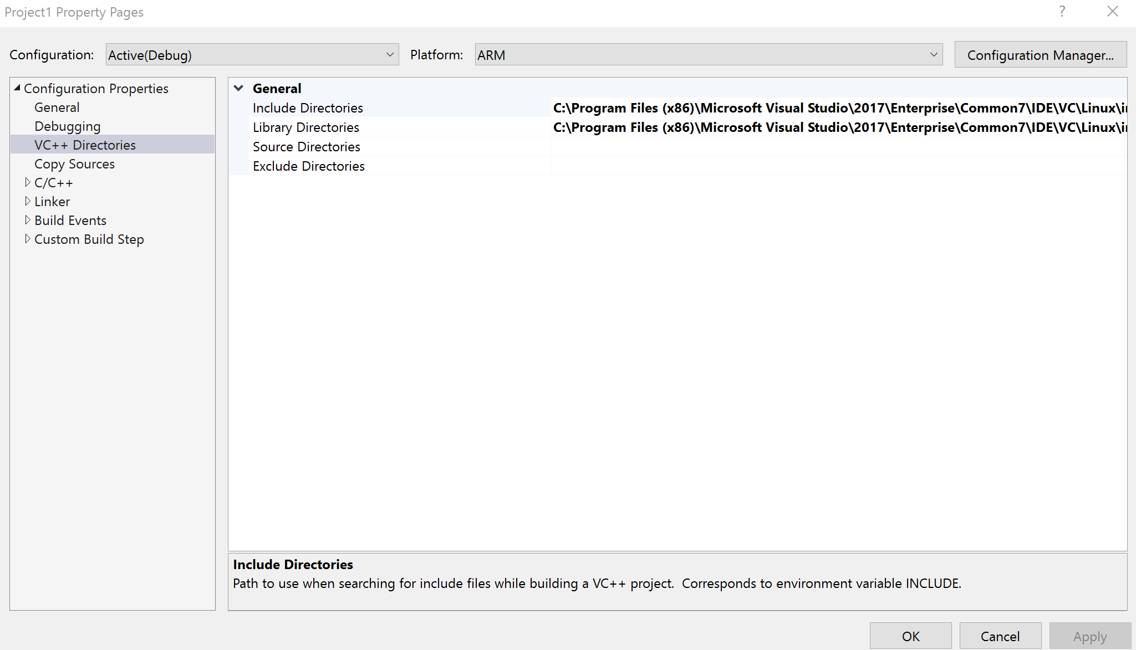

2.7 in the Library Directories-🡪

C:\Program Files (x86)\Microsoft Visual Studio\2017\Enterprise\Common7\IDE\VC\Linux\include\usr\local\lib

This address includes the .lib .so file or the project.

Notice: the previous two steps is to set the .hpp and library document in your computer to the include path. Then, you don’t need to include every .hpp in the project.

2.8 In C/C++-🡪General

/usr/include;.;/usr/local/include/djiosdk/;/usr/local/include/libusb-1.0;%(AdditionalIncludeDirectories)

The address depends on the project. I have reserved an (include) document in the resource for you.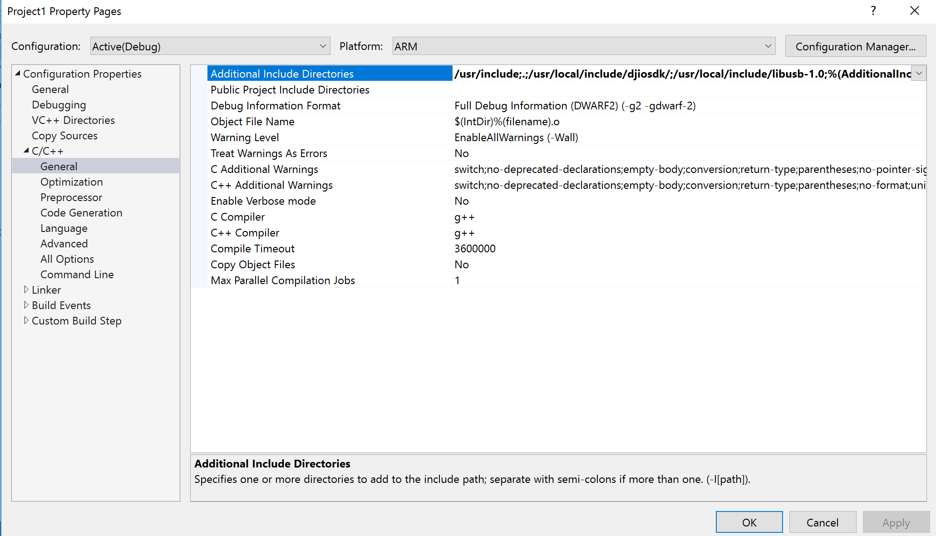

2.9 In Linker--🡪 additional Library Directories

Add the path: /usr/local/lib;%(AdditionalLibraryDirectories)

Notice: the previous two steps is to set the .hpp and library document in RPI to the include path. Then, g++ compiler can find this .hpp and .lib to complie.

3.0 change into ARM as the picture showed.



Notice:

1. The visual studio development tools will use the gdb, or gdbserver in Linux. So, using

sudo apt-get install gcc g++ gdb gdbvserver

Make sure we have installed everything we need for compelling.

8. introduction to the project code

//main.cpp

#include "control_l.h"

using namespace DJI::OSDK;

using namespace DJI::OSDK::Telemetry;

/*! main

*

*/

int

main(int argc, char** argv)

{

// Initialize variables

int functionTimeout = 1;

// Setup OSDK.

LinuxSetup linuxEnvironment(argc, argv);

// get the vehicle information

Vehicle* vehicle = linuxEnvironment.getVehicle();

if (vehicle == NULL)

{

std::cout << "Vehicle not initialized, exiting.\n";

return -1;

}

//begin guidacne

std::cout << "show distance below" << std::endl;

obstacle();

// Obtain Control Authority

vehicle->obtainCtrlAuthority(functionTimeout);

// test options

std::cout

<< "| Available commands: |"

<< std::endl;

std::cout

<< "| [a] Monitored Takeoff + Landing1 |"

<< std::endl;

std::cout

<< "| [b] Monitored Takeoff + Position Control + Landing |"

<< std::endl;

std::cout

<< "| [c] test using guidance |"

<< std::endl;

char inputChar;

std::cin >> inputChar;

notice!: if you don’t end guidance properly, the guidance may not work in the next time, so Restart the Guidance, if quit improperly last time, i.e. the data transfer thread quit before stop_transfer() and release_transfer().

switch (inputChar)

{

case 'a':

//usleep(11000000);

monitoredTakeoff(vehicle);

usleep(7000000); //7s time, is too short to landing, solved this problem

monitoredLanding(vehicle);

break;

case 'b':

// usleep(11000000);

monitoredTakeoff(vehicle);

usleep(5000000);

vehicle->control->attitudeAndVertPosCtrl(0, 0, 0, 1.2);

// moveByPositionOffset(vehicle, 1, 0, 1.2, 0);

usleep(1000);

// moveByPositionOffset(vehicle, 0, 1, 1.2, 0);

usleep(1000);

monitoredLanding(vehicle);

break;

case 'c':

test_using_data();// just use to test if guidance works well or not

default:

break;

}

end_guidance(); //

return 0;

}

#include "control_l.h"

#include <stdio.h>

#include <string>

#include <cstring>

#include <iostream>

#include <DJI_guidance.h>

#include "DJI_utility.h"

using namespace DJI::OSDK;

using namespace DJI::OSDK::Telemetry;

using namespace std;

void test_using_data();

int WIDTH = 320;

int HEIGHT = 240;

#define IMAGE_SIZE (HEIGHT * WIDTH)

#define USE_GUIDANCE_ASSISTANT_CONFIG 0 //use GUIDANCE ASSISTANT's configure

#define SELECT_DEPTH_DATA 1

e_vbus_index sensor_id = e_vbus1;

DJI_lock g_lock;

DJI_event g_event;

char key = 0;

position_info A;



std::ostream& operator<<(std::ostream& out, const e_sdk_err_code value) {

const char* s = 0;

static char str[100] = { 0 };

#define PROCESS_VAL(p) case(p): s = #p; break;

switch (value) {

PROCESS_VAL(e_OK);

PROCESS_VAL(e_load_libusb_err);

PROCESS_VAL(e_sdk_not_inited);

PROCESS_VAL(e_disparity_not_allowed);

PROCESS_VAL(e_image_frequency_not_allowed);

PROCESS_VAL(e_config_not_ready);

PROCESS_VAL(e_online_flag_not_ready);

PROCESS_VAL(e_stereo_cali_not_ready);

PROCESS_VAL(e_libusb_io_err);

PROCESS_VAL(e_timeout);

default:

strcpy(str, "Unknown error");

s = str;

break;

}

#undef PROCESS_VAL

return out << s;

}

If you want to get value from the guidance, use memcpy, copy the value to other place

Callback function prototype. The developer must write his/her own callback function in this form. In order to achieve best performance, it is suggested not performing any time-consuming processing in the callback function, but only copying the data out. Otherwise the transfer frequency might be slowed down.

int my_callback(int data_type, int data_len, char *content)

{

g_lock.enter();

if (e_image == data_type && NULL != content)

{

image_data* data = (image_data*)content;

// printf( "frame index:%d,stamp:%d\n", data->frame_index, data->time_stamp );

}

if (e_obstacle_distance == data_type && NULL != content)

{

obstacle_distance *oa = (obstacle_distance*)content;

// printf( "obstacle distance(m):" );

for (int i = 0; i < CAMERA_PAIR_NUM; ++i)

{

// printf(" %f ", 0.01f * oa->distance[i]);

float a = 0.01f * oa->distance[i];

/* cout << "size" << endl;

cout << sizeof(a) << endl;

cout << sizeof(A.obstacle_p[1]) << endl;

*/

memcpy(&A.obstacle_p[i], &a, sizeof(a));

}

// printf( "\n" );

// printf( "frame index:%d,stamp:%d\n", oa->frame_index, oa->time_stamp );

}

if (e_ultrasonic == data_type && NULL != content)

{

ultrasonic_data *ultrasonic = (ultrasonic_data*)content;

for (int d = 0; d < CAMERA_PAIR_NUM; ++d)

{

//printf("ultrasonic distance(m):%f,reliability:%d\n", ultrasonic->ultrasonic[d] * 0.001f, (int)ultrasonic->reliability[d]);

float a = ultrasonic->ultrasonic[d] * 0.001f;

memcpy(&A.ultrasonic_p[d], &a, sizeof(a));

}

//printf( "frame index:%d,stamp:%d\n", ultrasonic->frame_index, ultrasonic->time_stamp );

}

if (e_motion == data_type && NULL != content) {

motion* m = (motion*)content;

//printf("(px,py,pz)=(%.2f,%.2f,%.2f)\n", m->position_in_global_x,m->position_in_global_y,m->position_in_global_z);

}

g_lock.leave();

g_event.set_event();

return 0;

}

Subscribe ultrasonic data

Subscribe obstacle distance.

Subscribe global motion data, i.e. velocity and position of Guidance in global coordinate system.

#define RETURN_IF_ERR(err_code) { if( err_code ){ release_transfer(); \

std::cout<<"Error: "<<(e_sdk_err_code)err_code<<" at "<<__LINE__<<","<<__FILE__<<std::endl; return -1;}}

int obstacle()

{

reset_config(); // clear all data subscription

//NEC

int err_code = init_transfer(); //wait for board ready and init transfer thread

RETURN_IF_ERR(err_code);

//show the situation of guidance

int online_status[CAMERA_PAIR_NUM];

err_code = get_online_status(online_status);

RETURN_IF_ERR(err_code);

cout << "Sensor online status: ";

for (int i = 0; i<CAMERA_PAIR_NUM; i++)

cout << online_status[i] << " ";

cout << endl;

select_ultrasonic();

select_obstacle_distance();

select_motion();

//start to show the value

err_code = set_sdk_event_handler(my_callback);

RETURN_IF_ERR(err_code);

err_code = start_transfer();

RETURN_IF_ERR(err_code);

//wait for ten seconds

sleep(1000000);

test_using_data();

return 0;

}

Inform Guidance to stop data transfer

Release the data transfer thread.

void end_guidance()

{

g_event.wait_event();

/*cout << "key ?" << endl;

cin >> key;*/

if (key > 0) {

key = 0;

}

stop_transfer();

//RETURN_IF_ERR(err_code);

//make sure the ack packet from GUIDANCE is received

sleep(1000000);

release_transfer();

//RETURN_IF_ERR(err_code);

printf("safety clean");

}

void test_using_data()

{

for (int i = 0; i < 5; i++)

std::cout << "obstacle" << A.obstacle_p[i] << endl;

for (int i = 0; i < 5; i++)

std::cout << "ultrasonic" << A.ultrasonic_p[i] << endl;

}

Use guidance’s ultrasonic to get the height

Notice: the takeoff is same as the function in DJI GO, take off to about 1.2 meters height

bool

monitoredTakeoff(Vehicle* vehicle, int timeout)

{

//@todo: remove this once the getErrorCode function signature changes

char func[50];

// no pkgindex

ACK::ErrorCode takeoffStatus = vehicle->control->takeoff(timeout);

if (ACK::getError(takeoffStatus) != ACK::SUCCESS)

{

ACK::getErrorCodeMessage(takeoffStatus, func);

return false;

}

// First check: Motors started

int motorsNotStarted = 0;

int timeoutCycles = 20;

// M100 // First check: Motors started

while ((vehicle->broadcast->getStatus().flight < DJI::OSDK::VehicleStatus::M100FlightStatus::TAKEOFF) && motorsNotStarted < timeoutCycles)

{

// getstatus return status enum. stopped=0; on_groud =1. in air=2

motorsNotStarted++;

usleep(100000);

}

if (motorsNotStarted < timeoutCycles)

{

std::cout << "Successful TakeOff!" << std::endl;

}

// Second check: In air

int stillOnGround = 0;

timeoutCycles = 110;

while ((vehicle->broadcast->getStatus().flight !=

DJI::OSDK::VehicleStatus::M100FlightStatus::IN_AIR_STANDBY) &&

stillOnGround < timeoutCycles)

{

stillOnGround++;

usleep(100000);

}

if (stillOnGround < timeoutCycles)

{

std::cout << "Aircraft in air!!" << std::endl;

}

// Final check: Finished takeoff

float32_t delta;

float currentheight = 0;

float deltaheight = A.ultrasonic_p[0];

do

{

sleep(100000);//microsecond

currentheight = A.ultrasonic_p[0];

delta = fabs(currentheight - deltaheight);

deltaheight = currentheight;

} while (delta >= 0.010);

std::cout << "Aircraft hovering at " << A.ultrasonic_p[0] << "m!\n";

return true;

}

Use this function to land

monitoredLanding(Vehicle* vehicle, int timeout)

{

char func[50];

int pkgIndex;

std::cout << "enter landing fucntion" << std::endl;

ACK::ErrorCode landingStatus = vehicle->control->land(timeout);

if (ACK::getError(landingStatus) != ACK::SUCCESS)

{

ACK::getErrorCodeMessage(landingStatus, func);

return false;

}

// First check: Landing started

int landingNotStarted = 0;

int timeoutCycles = 20;

while (vehicle->broadcast->getStatus().flight !=

DJI::OSDK::VehicleStatus::M100FlightStatus::LANDING &&

landingNotStarted < timeoutCycles)

{

landingNotStarted++;

usleep(100000);

}

if (landingNotStarted == timeoutCycles)

{

std::cout << "Landing failed. Aircraft is still in the air." << std::endl;

// Cleanup before return

ACK::ErrorCode ack = vehicle->subscribe->removePackage(pkgIndex, timeout);

if (ACK::getError(ack))

{

std::cout << "Error unsubscribing; please restart the drone/FC to get "

"back to a clean state.\n";

}

return false;

}

else

{

std::cout << "Landing...\n";

}

// M100

while (vehicle->broadcast->getStatus().flight ==

DJI::OSDK::VehicleStatus::M100FlightStatus::FINISHING_LANDING)

{

sleep(1);

}

//may change to altitude

double gp = 0;

do

{

sleep(2);

gp = A.ultrasonic_p[0];

if (A.ultrasonic_r[0] = 0)

gp = 2;

std::cout << "inthesecondcheck" << std::endl;

} while (gp > 0.15);

if (gp > 0.15)

{

std::cout

<< "Landing finished, but the aircraft is in an unexpected mode. "

"Please connect DJI GO.\n";

return false;

}

else

{

std::cout << "Successful landing!\n";

}

return true;

}

Notification:

1.

In utility.hpp file In utility.cpp

position_info::position_info()

{

this->motion_x = 0;

this->motion_y = 0;

this->motion_z = 0;

for (int i = 0; i < 5; i++)

{

this->obstacle_p[i];

this->ultrasonic_p[i];

this->ultrasonic_r[i];

}

}

class position_info

{

private:

public:

position_info();

//for obstacle_distance

float obstacle_p[camera];

//float obstacle_right;

//float obstacle_rear;

//float obstacle_left;

//float obstacle_down;

//ultrasonic distance

float ultrasonic_p[camera];

int ultrasonic_r[camera];

//motion_position

float motion_x;

float motion_y;

float motion_z;

};

The guidance has five sensors in five directions. In my code, I set the i=1, is the front VBUS 1; i=2, is the right VBUS 2; i=3, is the rear VBUS 3; i=4, is the rear VBUS 4; i=0, is the underside VBUS 0;

2. about Onboard-SDK function:

1.1 void flightCtrl (AdvancedCtrlData data)

Control the vehicle using user-specified mode (overloaded). All control functions are based on this flightctrl function. When reference frame is the DJI::OSDK::Control::HORIZONTAL_GROUND (NEU), the drone may use fusion data with GPS. However, the GPS does not work indoor.

For example,  void positionAndYawCtrl (float32_t x, float32_t y, float32_t z, float32_t yaw)

Control the position and yaw angle of the vehicle. The reference frame is the DJI::OSDK::Control::HORIZONTAL_GROUND (NEU) and it uses GPS to control the position.

void velocityAndYawRateCtrl (float32_t Vx, float32_t Vy, float32_t Vz, float32_t yawRate) is similar as the last one. Only void attitudeAndVertPosCtrl (float32_t roll, float32_t pitch, float32_t yaw, float32_t z), it control the attitude and vertical position of the vehicle, and it only use compass to get its own body position, that is confirmed by asking dev.support. However, the compass works poorly indoor due to the intricate magnetic interfaces. The current solution could be using guidance to help M100 get the right position, then, use other ultrasonic sensors to detect the position.

From youtube, there is a dji guidance optic flow testing in warehouse, the link is <https://www.youtube.com/watch?v=V94zsX3wh_I>

If the drone flies above textured ground, it can stably stay in a position. If the drone flies over monochrome surfaces, transparent surface, or surface without clear patterns or texture, it will lose control.

1.2 list of function which is not suitable for M100

1.2.1 all the function related subscription

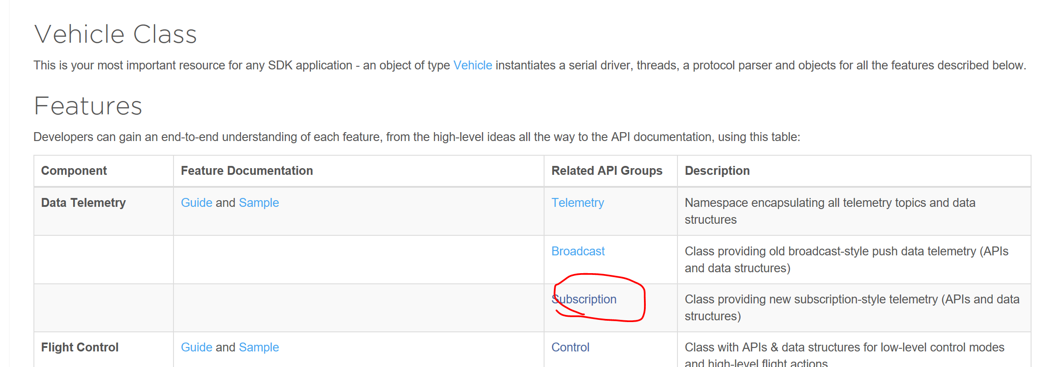

1.2.2 M100 does not have RTK function

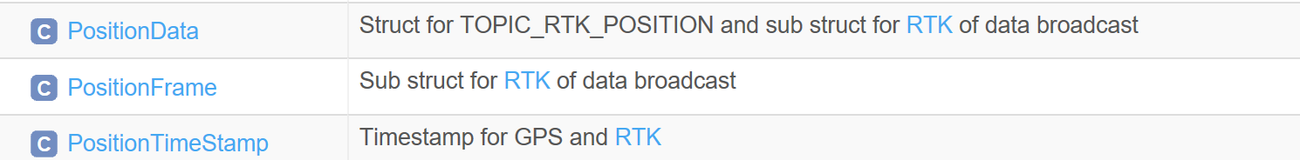

1.2.3 do not use any function about GPS indoor

1.2.4 DJI::OSDK::Telemetry::RelativePosition

This function is supposed to get the obstacle distance back from the M100 uart port. But, I have tested it and confirmed with dev.support. This function does not support M100

1.2.5 void Control::emergencyBrake()

1.2.6 DJI::OSDK::Telemetry::RC

bool

moveByPositionOffset(Vehicle *vehicle, float xOffsetDesired, float yOffsetDesired, float zOffsetDesired, float yawDesired, float posThresholdInM, float yawThresholdInDeg)

{

int responseTimeout = 1;

int timeoutInMilSec = 10000;

int controlFreqInHz = 50; // Hz

int cycleTimeInMs = 1000 / controlFreqInHz;

int pkgIndex;

int outOfControlBoundsTimeLimit = 10 * cycleTimeInMs; // 10 cycles

int withinControlBoundsTimeReqmt = 50 * cycleTimeInMs; // 50 cycles

float distancex = 3;

float distancey = 3;

double pitch = -1;

double roll = -1;

// decision for movement method

// move forward, xsetdesired

if (xOffsetDesired > 0)

{

pitch = -1; //fly forward;

roll = 0;

}

else if (yOffsetDesired > 0)

{

pitch = 0; //fly right; doesn't test

roll = -1;

}

char func[50];

// Wait for data to come in

sleep(1); //not sure

//current position and original position

position_info current_position;

//position_info origin_position = A;

// Convert position offset from first position to local coordinates

// Get initial offset. We will update this in a loop later.

double xOffsetRemaining = 0;

double yOffsetRemaining = 0;

// Conversions

double yawDesiredRad = DEG2RAD * yawDesired;

double yawThresholdInRad = DEG2RAD * yawThresholdInDeg;

Telemetry::Quaternion broadcastQ;

double yawInRad;

broadcastQ = vehicle->broadcast->getQuaternion();

yawInRad = toEulerAngle((static_cast<void*>(&broadcastQ))).z / DEG2RAD;

int elapsedTimeInMs = 0;

int withinBoundsCounter = 0;

int outOfBounds = 0;

// There is a deadband in position control

More detail is after this section, which explain how to use control position velocity and function

if (xOffsetDesired > 0)

{

do {

distancex = A.obstacle_p[1];

distancey = A.obstacle_p[2];

vehicle->control->attitudeAndVertPosCtrl(0, pitch, 0, zOffsetDesired);

//current_position = A;

std::cout << "distancee" << distancex << std::endl;

usleep(cycleTimeInMs * 1000);

elapsedTimeInMs += cycleTimeInMs;

broadcastQ = vehicle->broadcast->getQuaternion();

yawInRad = toEulerAngle((static_cast<void*>(&broadcastQ))).z;

//set current

if (distancex < xOffsetDesired)

{

std::cout << "break" << std::endl;

break;

}

//posthresholadinM= 0.2 ;1

//localOffsetFromOffset(vehicle, localOffset, &current_position, &origin_position);

//currentBroadcastGP = vehicle->broadcast->getGlobalPosition();

//currentBroadcastGP = vehicle->broadcast->getGlobalPosition();

xOffsetRemaining = distancex - xOffsetDesired;

if (std::abs(xOffsetRemaining) < posThresholdInM && std::abs(yOffsetRemaining) < posThresholdInM)

{

//! 1. We are within bounds; start incrementing our in-bound counter

//1000 cycletimeinms

withinBoundsCounter += cycleTimeInMs;

std::cout << "increase cycletimeinms" << std::endl;

pitch = 0.1;

}

else

{

if (withinBoundsCounter != 0)

{

//! 2. Start incrementing an out-of-bounds counter

outOfBounds += cycleTimeInMs;

}

}

//! 3. Reset withinBoundsCounter if necessary

//2. 10000

if (outOfBounds > outOfControlBoundsTimeLimit)

{

withinBoundsCounter = 0;

outOfBounds = 0;

}

//! 4. If within bounds, set flag and break. final decision made

if (withinBoundsCounter >= withinControlBoundsTimeReqmt)

{

break;

}

} while (distancex > xOffsetDesired);

}

else if (yOffsetDesired > 0)

{

do {

distancex = A.obstacle_p[1];

distancey = A.obstacle_p[2];

vehicle->control->attitudeAndVertPosCtrl(roll, 0, 0, zOffsetDesired);

//current_position = A;

std::cout << "distancey" << distancey << std::endl;

usleep(cycleTimeInMs * 1000);

elapsedTimeInMs += cycleTimeInMs;

broadcastQ = vehicle->broadcast->getQuaternion();

yawInRad = toEulerAngle((static_cast<void*>(&broadcastQ))).z;

//set current

if (distancey < yOffsetDesired)

{

std::cout << "break" << std::endl;

break;

}

//posthresholadinM= 0.2 ;1

yOffsetRemaining = distancey - yOffsetDesired;

if (std::abs(xOffsetRemaining) < posThresholdInM && std::abs(yOffsetRemaining) < posThresholdInM)

{

//! 1. We are within bounds; start incrementing our in-bound counter

//1000 cycletimeinms

withinBoundsCounter += cycleTimeInMs;

std::cout << "increase cycletimeinms" << std::endl;

pitch = 0.1;

}

else

{

if (withinBoundsCounter != 0)

{

//! 2. Start incrementing an out-of-bounds counter

outOfBounds += cycleTimeInMs;

}

}

//! 3. Reset withinBoundsCounter if necessary

//2. 10000

if (outOfBounds > outOfControlBoundsTimeLimit)

{

withinBoundsCounter = 0;

outOfBounds = 0;

}

//! 4. If within bounds, set flag and break. final decision made

if (withinBoundsCounter >= withinControlBoundsTimeReqmt)

{

break;

}

} while (distancey > yOffsetDesired);

}

else

{

std::cout << "cannot move to any position, error!!";

}

int x = 0;

int y = 0;

if (xOffsetDesired > 0)

{

while (x<5)

{

vehicle->control->attitudeAndVertPosCtrl(0, 0.5, 0, zOffsetDesired);// degree position, move back.

std::cout << "stop.x" << std::endl;

usleep(100000);

x++;

}

}

else if (yOffsetDesired > 0)

{

while (y<5)

{

vehicle->control->attitudeAndVertPosCtrl(0.5,0, 0, zOffsetDesired);// degree position, move back.

std::cout << "stop.y" << std::endl;

usleep(100000);

y++;

}

}

// vehicle->control->positionAndYawCtrl(0, 0, 0, yawDesiredRad / DEG2RAD);

if (elapsedTimeInMs >= timeoutInMilSec)

{

std::cout << "position movement Task timeout!\n";

return ACK::FAIL;

}

return ACK::SUCCESS;

}

Resource: all the code can be found in Projects/visualproject/Project1, which is my final production. However, this version combines with guidance-SDK and onboard-SDK. You may start your own code starting from Projects\Project2.

Result presentation:

safety cleanpi@raspberrypi:~ $ ./testboot.sh

Read App ID

User Configuration read successfully.

STATUS/1 @ init, L55: Attempting to open device /dev/ttyS0 with baudrate 230400...

STATUS/1 @ init, L65: ...Serial started successfully.

STATUS/1 @ parseDroneVersionInfo, L687: Device Serial No. = 041DE52321

STATUS/1 @ parseDroneVersionInfo, L689: Hardware = M100

STATUS/1 @ parseDroneVersionInfo, L690: Firmware = 3.1.10.0

STATUS/1 @ parseDroneVersionInfo, L693: Version CRC = 0xA6453AAC

STATUS/1 @ initSubscriber, L738: Telemetry subscription mechanism is not supported on this platform!

STATUS/1 @ initMFIO, L941: MFIO is not supported on this platform!

STATUS/1 @ initHardSync, L1003: Hardware Sync is not supported on this platform!

STATUS/1 @ activate, L1239: version 0x3010A00

STATUS/1 @ activate, L1252: Activation successful

show distance below

llibusb_get_device_list ret = 5 !!!

Waiting for board ready...

Sensor online status: 1 1 1 1 1

obstacle80

obstacle2.05

obstacle80

obstacle80

obstacle1.61

ultrasonic0.1

ultrasonic2.572

ultrasonic-0.001

ultrasonic-0.001

ultrasonic2.181

| Available commands: |

| [a] Monitored Takeoff + Landing1 |

| [b] Monitored Takeoff + Position Control + Landing |

| [c] test using guidance |

a

a

Aircraft hovering at 0.1m!

Explain of control class:

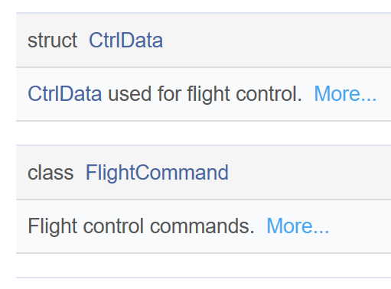

Ctrldata and flightcommand give the direct way to control the drone’s movement. The best way to learn how to use these two is looking through the cpp file in Onboard-SDK-3.6\osdk-core\api\src.

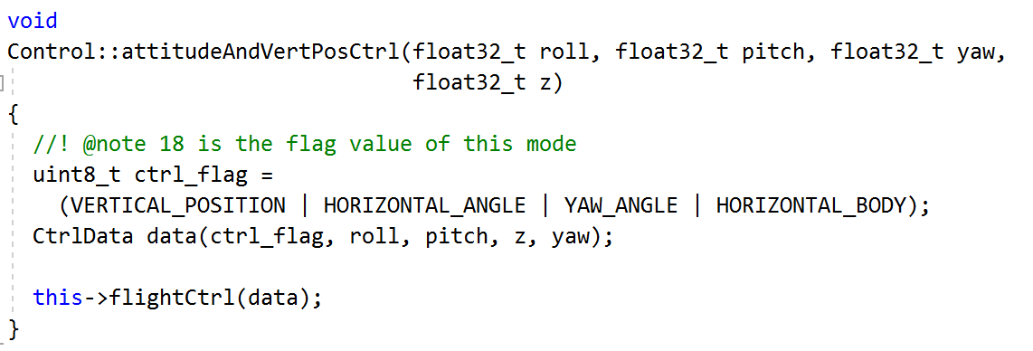

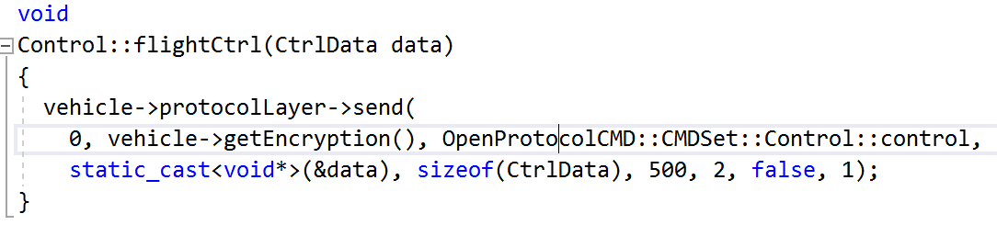

This teaches you how to use ctrl_flag and ctrldata, you can build your own function based on this method. However, I don’t think it’s necessary to do that.

You also need to know what is YAW, ROLL, PITCH and THROTTLE.

Body Coordinate System

The body coordinate system is relative to the aircraft itself. Three perpendicular axes are defined such that the origin is the center of mass, and the **X** axis is directed through the front of the aircraft and the **Y** axis through the right of the aircraft. Using the [coordinate right hand rule](https://en.wikipedia.org/wiki/Right-hand_rule), the **Z** axis is then through the bottom of the aircraft.

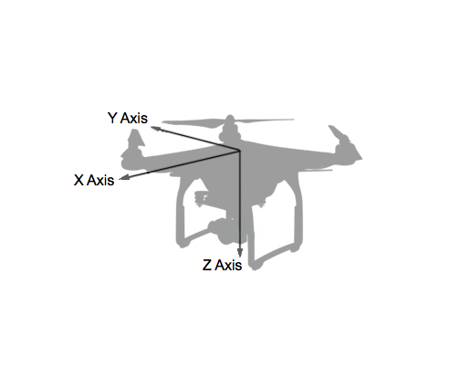

Aircraft translation in positive X, Y and Z is therefore defined in the Body Coordinate System as forward, right and downward translation respectively.

Aircraft rotation is also described with these same axes using the [coordinate right hand rule](https://en.wikipedia.org/wiki/Right-hand_rule) to define the direction of positive rotation. When describing rotational movement, the X, Y and Z axes are renamed **Roll**, **Pitch** and **Yaw**.

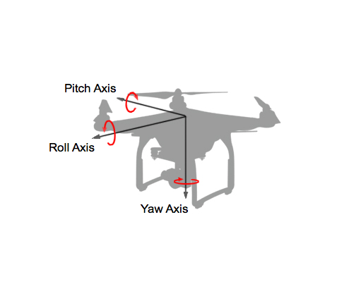

The definition of X, Y, Z, roll, pitch and yaw is consistent with aircraft body coordinate systems, but can sometimes be unintuitive to a developer seeing it for the first time.

For instance, if the aircraft rotates around the Pitch axis (Y axis) it will move in the X axis direction. Moreover, if the Pitch angle is positive, the direction will be backwards, or in the negative X axis. Care must therefore be taken when using roll, pitch and yaw to move an aircraft.

Resource:

<https://developer.dji.com/mobile-sdk/documentation/introduction/flightController_concepts.html>

<https://developer.dji.com/onboard-sdk/documentation/guides/component-guide-flight-control.html>

<https://developer.dji.com/onboard-api-reference/classDJI_1_1OSDK_1_1Control.html>

raspberry pi setup (software)

Include

1. download Guidance and Onboard-SDK from github.com

1.1 use gitclone + address to download the file into RPI

Like: git clone <https://www.github.com/dji-sdk/Onboard-SDK>

git clone <https://github.com/dji-sdk/Guidance-SDK>

1.2 check your document in RPI, showed in picture

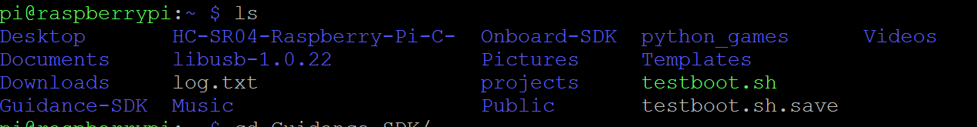

notice: the Onboard-SDK version is 3.6

the guidance version is the newest version

2. using WinSCP check the file path

2.1 Download and install the WinSCP software from <https://winscp.net/eng/download.php>

WinSCP is a popular free SFTP and FTP client for Windows, a powerful file manager that will improve your productivity. It offers an easy to use GUI to copy files between a local and remote computer using multiple protocols: Amazon S3, FTP, FTPS, SCP, SFTP or WebDAV. Power users can automate WinSCP using .NET assembly.

We use WinSCP to check files in RPI as a way to look through file in Windows. It can help us same much time

2.2 open WinSCP, and we use the same IP for SSH. The username is pi, the password is still raspberry

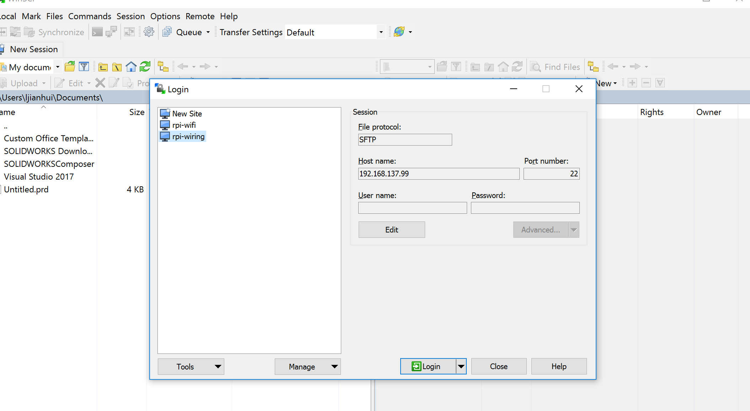

3. Download *libusb-1.0.9* library in raspberry pi and import the .so into the lib.

LIBUSB-1.0.9 SETUP

1.1 go to the sourceforce. The website is <https://sourceforge.net/projects/libusb/files/libusb-1.0/libusb-1.0.9/>

1.2 Open a LXTerminal (console) and move to the Downloads folder: cd Downloads/

1.3 Extract the libusb-1.0.19: tar –jxf libusb-1.0.9.tar.bz2

1.4 Change to the new libusb-1.0.19 directory where libusb was extracted: cd libusb-1.0.19/

1.5 ./configure --prefix=/usr --disable-static &&make

If Doxygen is installed and you wish to build the API documentation, issue the following command:

make -C doc docs

This package does not come with a test suite.

Now, as the root user:

make install

If you built the API documentation, install it using the following commands as the root user:

install -v -d -m755 /usr/share/doc/libusb-1.0.9/apidocs &&

install -v -m644 doc/html/* \

/usr/share/doc/libusb-1.0.9/apidocs

1.6 Back up the originally installed libusb (it has issues in combination with pylon): sudo mv libusb-1.0.so.0 libusb-1.0.so.0-org

Second method: you can just use the command below:

sudo apt-get install libusb-1.0-0-dev

it will help you install the latest usb-library, which also works.

Notice:

1. after you have extracted the libusb-1.0.9, you should see a read me file or other instruction.

2. if it shows permission denied, add sudo before the command.

3. if you meet the permission denied when you do the ./configure

Use chmod +x configure. chmod +x on a file (your script) only means, that you'll make it executable.

Resource:

<https://www.raspberrypi.org/forums/>

<http://www.linuxfromscratch.org/blfs/view/7.4/general/libusb.html>

4 setup the Guidance-SDK environment on RPI

1.1 Copy libDJI_guidance.so to "library file path" of your project.

Use the command: sudo cp Guidance-SDK/so/XU3/libDJI_guidance.so /usr/local/lib

The path: Guidance-SDK/so supports several versions for library. Here, we choose to use XU3. The RPI is arm architect, but the arm version is too old for RPI right now. If you use arm, some function may not be found. In the picture below, it teaches you how to check the symbol in .so library file.

Use nm -help to see the option of nano tools.

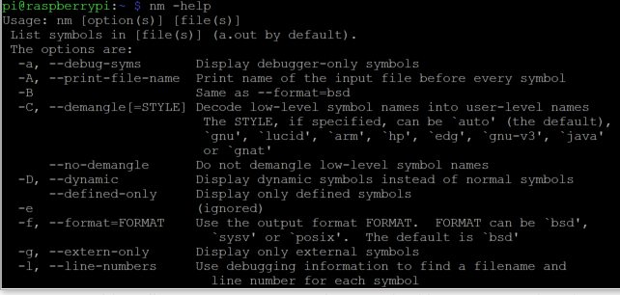

For example, the nm -D can help us check the dynamic symbols.

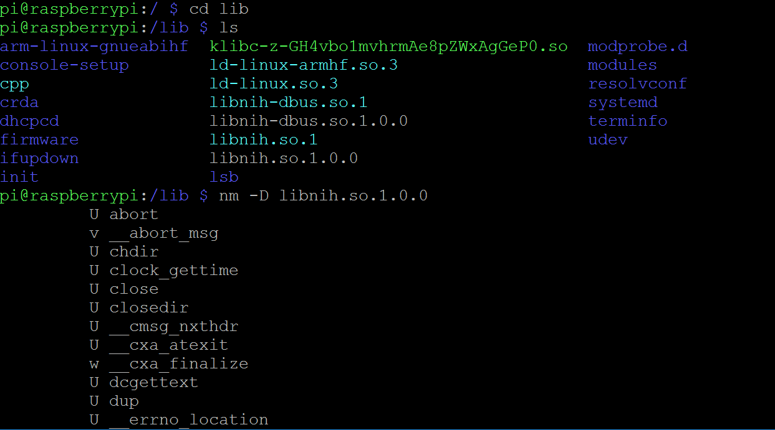

If you want to sift some special symbol, then use nm -D libnih.so.1.0.0 |grep image.

1.2 Copy DJI_guidance.h to "header file path".

Command: sudo cp Guidance-SDK/include/DJI_guidance.h /usr/local/include

Notice:

1. the part 4 is for you to use guidance_SDK. In the future, the guidance system will connect to M100. Because, the drone needs to get all output data from Guidance to keep the balance and stable position.

2. without sudo, the terminal will show you permission denied. When we use SSH to open the console, we are not the root user, in other words, we don’t have the access to system file. Therefore, we cannot use the WinSCP to move or copy the file into system files.

3. Also, do not use chmod 777 to change permissions, which will disturb the system.

5. Update all the software to the newest

1.1 sudo apt update && sudo apt upgrade

1.2 if you want to install some software

Using: sudo apt-get install xxxx

6. install text editor

1.1 highly recommend using nano, which is super-easily for new learner. Besides, vim and vi is also good editor.

notice: the Rapbian is a system specialized for RPI, which include most software needed for an RPI project. However, we still need to install some tools such as nano, libusb1.0.9 and VNCserver.

Resource: <https://www.hostinger.com/tutorials/how-to-install-and-use-nano-text-editor>

<https://www.linux.com/learn/vim-101-beginners-guide-vim>

9. Linux basic syntax

The list below is some common command using for the whole project. Once you know how this command working, you are ready to do more job

ls

cd cd .. cd ~

sudo

cp

sudo nano /xxx/xxx/xxx

g++ (for example g++ main.cpp -ldjiosdk-core)

./xxx/xxx/xxx.out (for example

cmake

mkdir xxxx

git clone xxxxxxxxx

sudo apt-get update

cat xxxx (for example cat main.cpp)

sudo raspi-config

sudo reboot (restart)

sudo shutdown -h now (shutdown the computer right now)

| grep xxx

resource:

<https://maker.pro/linux/tutorial/basic-linux-commands-for-beginners>

<https://www.linux.org/forums/linux-beginner-tutorials.123/>

10. g++ using

In this section, a sample test the connection between M100 and RPI, which will show you how to simply use g++ complier in Linux

1.1 In the main.cpp

In Linux system, in a console, cd to the file position, then use cat main.cpp, you can check the content of the .cpp file. This code below can be find in \DJI\raspberry pi

#include <djiosdk/dji_vehicle.hpp>

#include <iostream>

#include <djiosdk/dji_control.hpp>

using namespace std;

using namespace DJI::OSDK;

int main() {

Vehicle v("/dev/ttyAMA0", 115200, true, false);

ACK::DroneVersion version = v.getDroneVersion(1);

cout << version.data.hwVersion << endl;

return 0;

}

Notice: when you edit the main.cpp file in Linux system, make sure your computer using the English version. Other language version may cause the compatible problem.

1.2 g++ main.cpp -ldjiosdk-core -lpthread

-ldjiosdk-core means we need to use this library to complier the main.cpp, also the lpthread, which means the complier need to use pthread library. Pthread is parallel execution model. It allows a program to control multiple different flows of work that overlap in time. In the DJI M100 project, it is required.

After that, you can see a.out file

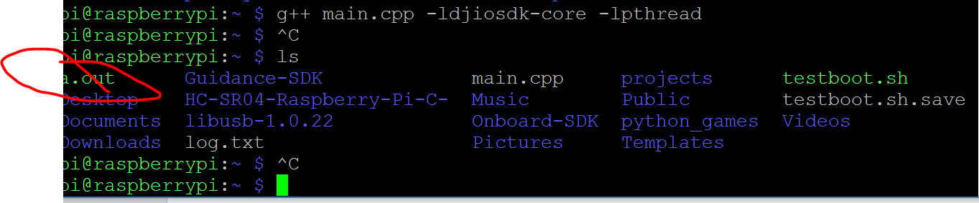

1.3 ./a.out

Then you can see, the RPI executes the file.

a.out is a file after compiled, which is convert from a c++ file into an assembly language file

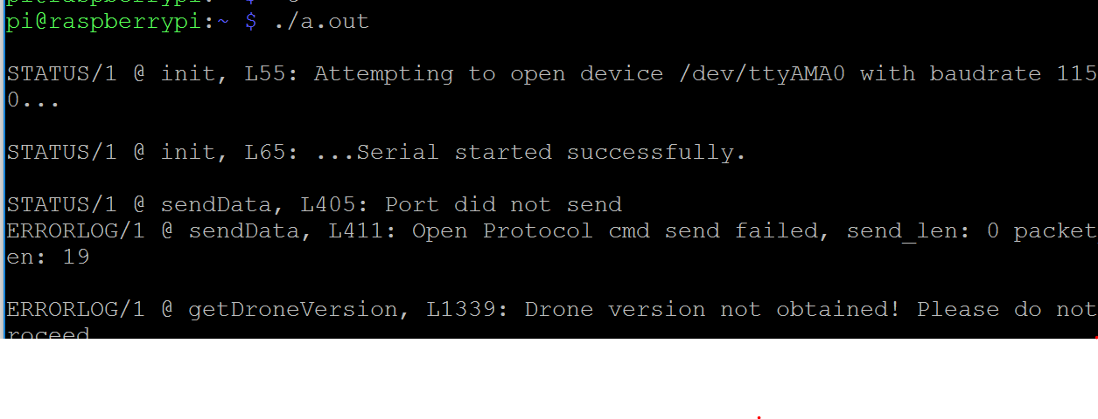

Notice:

1. if RPI notice it cannot find the -djiosdk-core, you need to manually copy the djiosdk-core library

2. in the local/lib and local/include, you should see guidance, djiosdk-core and libusb library in the local/lib file, the same as showed in picture.

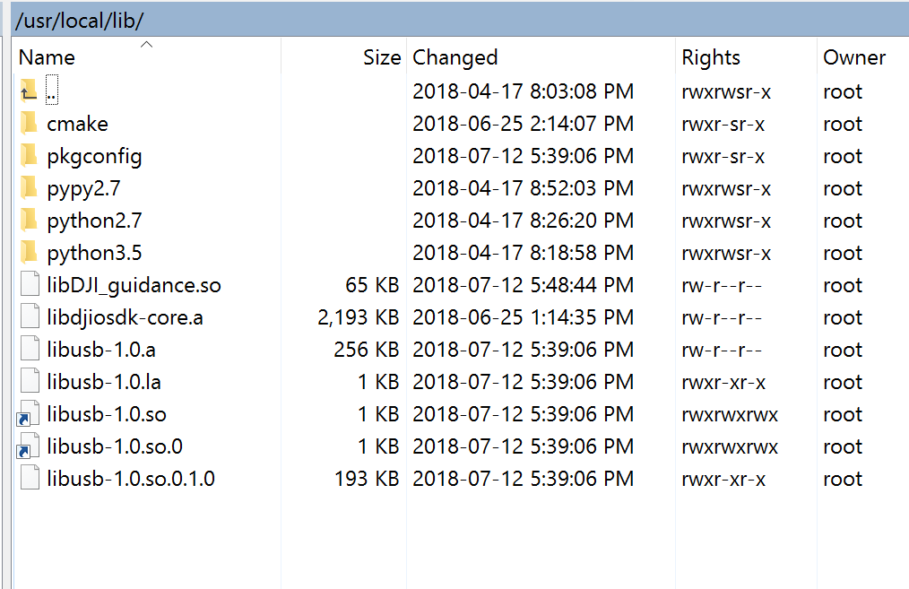

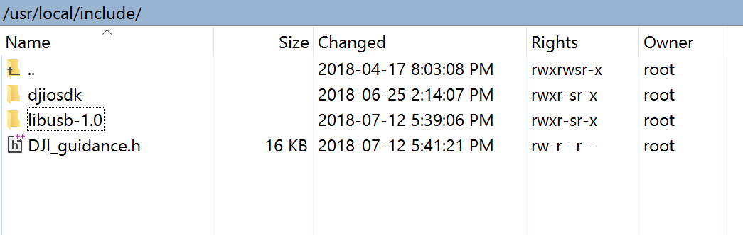

11. Reboot and a start-up script

Introduction: There are two easy methods to start up a function or a script when the RPI reboot.

1. rc.local

2. crontab

Before that, we need to build a led project to show us if we success or not.

1.1 build a LED blink project. In the Projects\Blink1, it has already prepared for you. Please compile it, you will see in the projects/Blink1/bin/ARM/Debug, there is a Blink1.out, which mean you success to compile it.

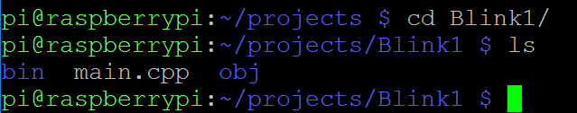



1.2 go to the rc.lc oal file, edit it as

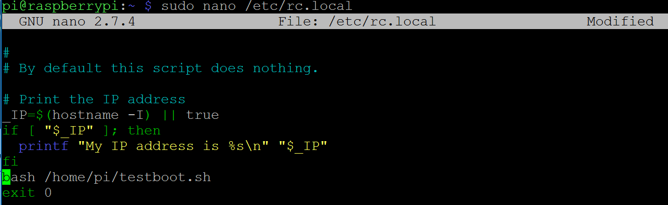

1.3 then we write a simple script named testboot.sh

sudo nano testboot.sh

then add the content into the document.

#!/bin/bash

echo 17 > /sys/class/gpio/export && sleep 0.1 && echo out > /sys/class/gpio/gpio17/direction

/home/pi/projects/Blink1/bin/ARM/Debug/Blink1.out

/usr/bin/logger Blinking

echo 17 > /sys/class/gpio/unexport

Notice:

1. why we need to export, then unexport?

Because, #include <wiringPi.h>, wiringPi.h has some problem with the port. Everytime we executive a port, for example, in this project, the port is gpio 17. wiringPi.h will not release the port after it takes the port. So we need to use echo 17 > /sys/class/gpio/unexport.

1.4 sudo reboot

To check whether it works or not.

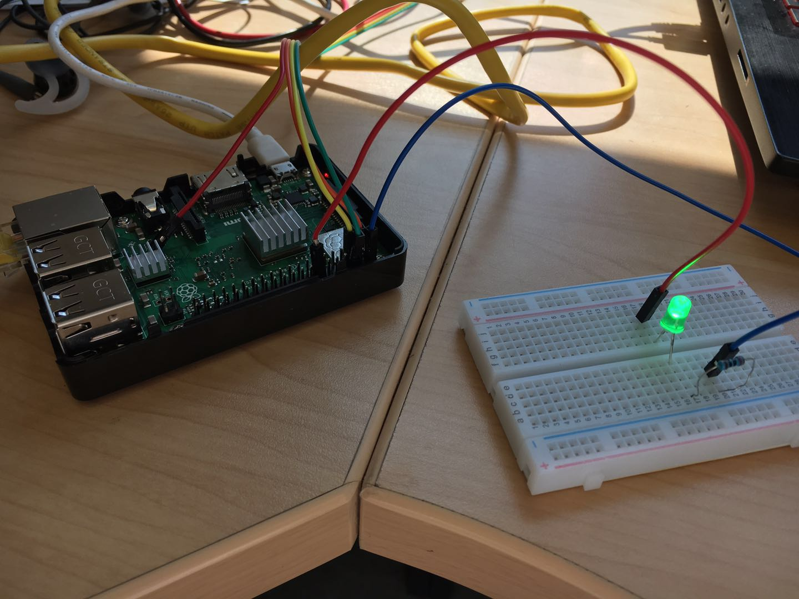

Resource:

<https://www.dexterindustries.com/howto/run-a-program-on-your-raspberry-pi-at-startup/>

<http://wiringpi.com/>

second method:

1.1 nano crontab -e

1.2 add :

@reboot cd /home/pi/projects/Blink1/bin/ARM/Debug && ./Blink1.out

Resource:

<https://learn.pimoroni.com/tutorial/sandyj/running-scripts-at-boot>

<https://www.cyberciti.biz/faq/linux-execute-cron-job-after-system-reboot/>

notice:

1. when we use testboot.sh as a script. We need to give a full permission to the file. So we need do this: sudo chmod 777 testboot.sh

2. for the rc.local, we can do:

Make your /etc/rc.local executable in case it is not already executable by

sudo chown root /etc/rc.local

sudo chmod 755 /etc/rc.local

Check everything works fine by executing

sudo /etc/init.d/rc.local start

12. Project with ultrasonic sensor

This project just to test if raspberry pi is possible to connect extra sensors.

1.1 The code is provided in projects/ultrasonic

#include <iostream>

#include <wiringPi.h>

#include "libSonar.h"

using namespace std;

int trigger = 2;

int echo = 3;

int main()

{

if (wiringPiSetupGpio() == -1)

return -1;

Sonar sonar;

sonar.init(trigger, echo);

while (1) {

cout << "Distance is " << sonar.distance(30000) << " cm." << endl; // 30000 is a timeout in microseconds

}

}

1.2 connect the correct pin number with the trigger and echo number.

Notice: in RPI, the number may be pin number or GPIO number, so you need to double check the code.

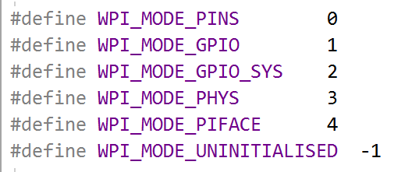

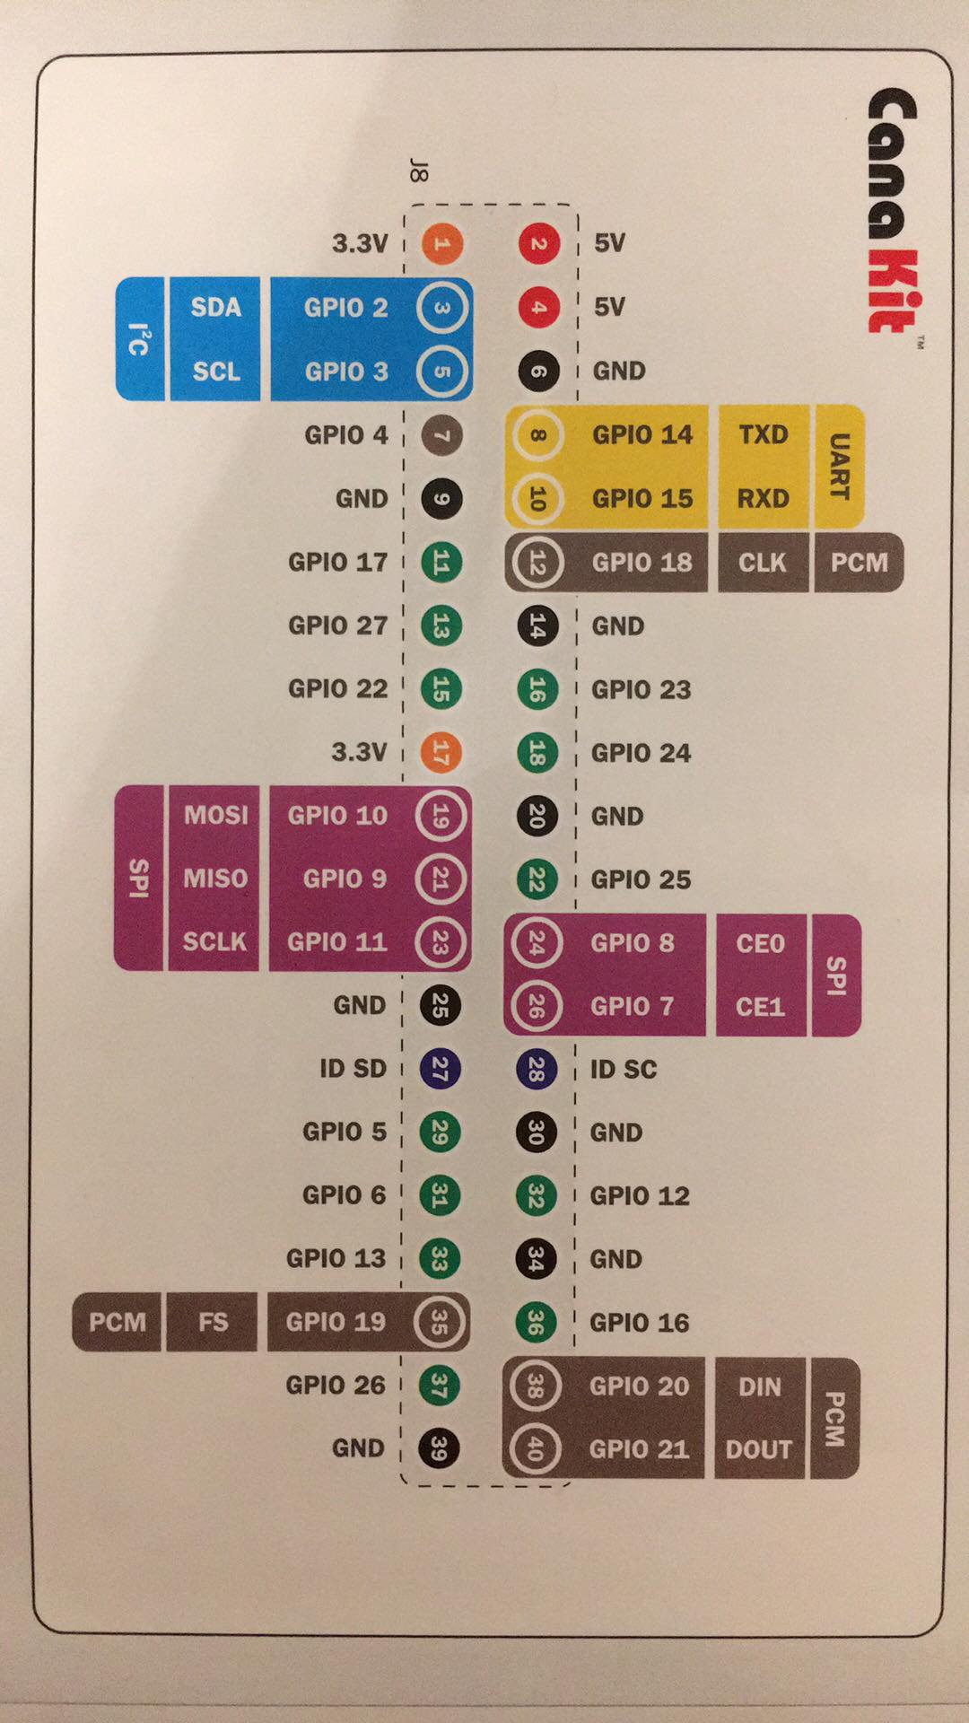

Guidacne-SDK:

1. Sample application:

Guidance SDK have provided examples to get data from Guidance system. This section guides you how to execute these examples. We use OpenCV to view the images transmitted from Guidance, so it is recommended to install OpenCV on your system. However, you can also get all the data except images if you don't have OpenCV.

We provide a CMakeLists.txt for both Linux and Windows system, which automatically detects if you have OpenCV installed.

1.1 usb setup on guidance assistant

User can use Guidance assistant software to subscribe the data in "DIY->API->USB" tab.

* + Connect Guidance with RPI using USB cable, power on the Guidance
  + Choose the "Enable" check box
  + Choose the data according your requirement

**Notes:** The available bandwidth is subject to the selection of image data and the output frequency. The selection of subscribed image data and output frequency will be saved and take effect when the Guidance system is turned off and on again.

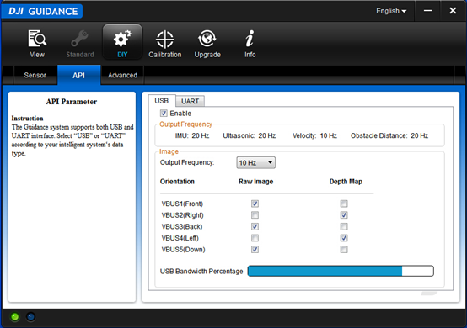

1.2 On RPI console, sue command below:

cd Guidance-SDK\examples\usb_example\DJI_guidance_example

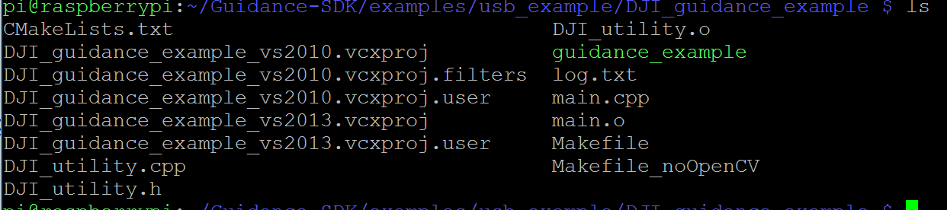

You should see guidance_example in the document.

If not, you can follow the instruction from official website:

cd Guidance-SDK\examples\usb_example\DJI_guidance_example

mkdir build

cd build

cmake ..

Build: a. On Linux, simple type: make b. On Windows, you'll see a solution file is generated. Open it and build the project dji_guidance_usb.

Notice:

1. in DJI guidance, you can only choose one mode between Standard and DIY. The M100 control system can get data from guidance system to help it estimate its position, and modify the flying-attitude. If you don’t connect the drone with guidance system, the drone may lose control indoor. So connecting guidance to the drone is my advice, then choose Standard.

However, if you want to use guidance as a peripheral sensors to get data, then choose DIY mode.



2. Restart the Guidance, if quit improperly last time, i.e. the data transfer thread quit before stop_transfer() and release_transfer().

In DJI’s sample, you should tyep “q” to quit the programming.

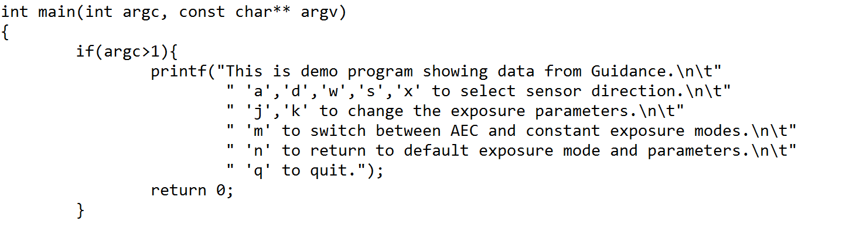

3. Examples of USB and UART can be found in examples/usb_example, examples/uart_example, including Makefile which is ready to compile. Remember to copy the corresponding libDJI_guidance.so file to the same directory where the output binary locates.

Notice that, reading and writing Guidance USB port in Linux requires root authority. To save the trouble of typing sudo every time running Guidance SDK applications, it is suggested to add a rule to /etc/udev/rules.d directory, which can be found in doc/51-guidance.rules. Or typing from terminal the following line

sudo sh -c 'echo "SUBSYSTEM==\"usb\", ATTR{idVendor}==\"fff0\", ATTR{idProduct}==\"d009\", MODE=\"0666\"" > /etc/udev/rules.d/51-guidance.rules'

Resource:

<https://developer.dji.com/guidance-sdk/documentation/quick-start/run-examples.html>

Conclusion:

First, after looking through the previous contents, anyone can know how to use Linux (raspberry pi), Onboard-SDK, Guidance-SDK and Linux development platform to control the M100. This report will give much convenience for beginner. If you know how to use raspberry or Linux, I highly recommend using ROS to control the drone and write the code.

Second, the Guidance system is an assistant system for Matrice 100 (N1 control system). Therefore, it is not optimal that reading data from the Guidance help control the drone. The drone flies unstably after leaving the guidance.

Third, the camera of guidance system is sensitive to the surface with texture, therefore, if conditions allow, the testing room should cover with strip-bar carpet. And an empty testing room is required which can increase the efficiency of project.

In addition, the new plan could be suing four laser ranging sensors, and each sensor has 45 degree angle with the body of drone. Then it is easy to be calculated the distance between the wall and drone. Also, the yaw angle of drone can be figured out. You can begin to do the project based on my project version 1-1.

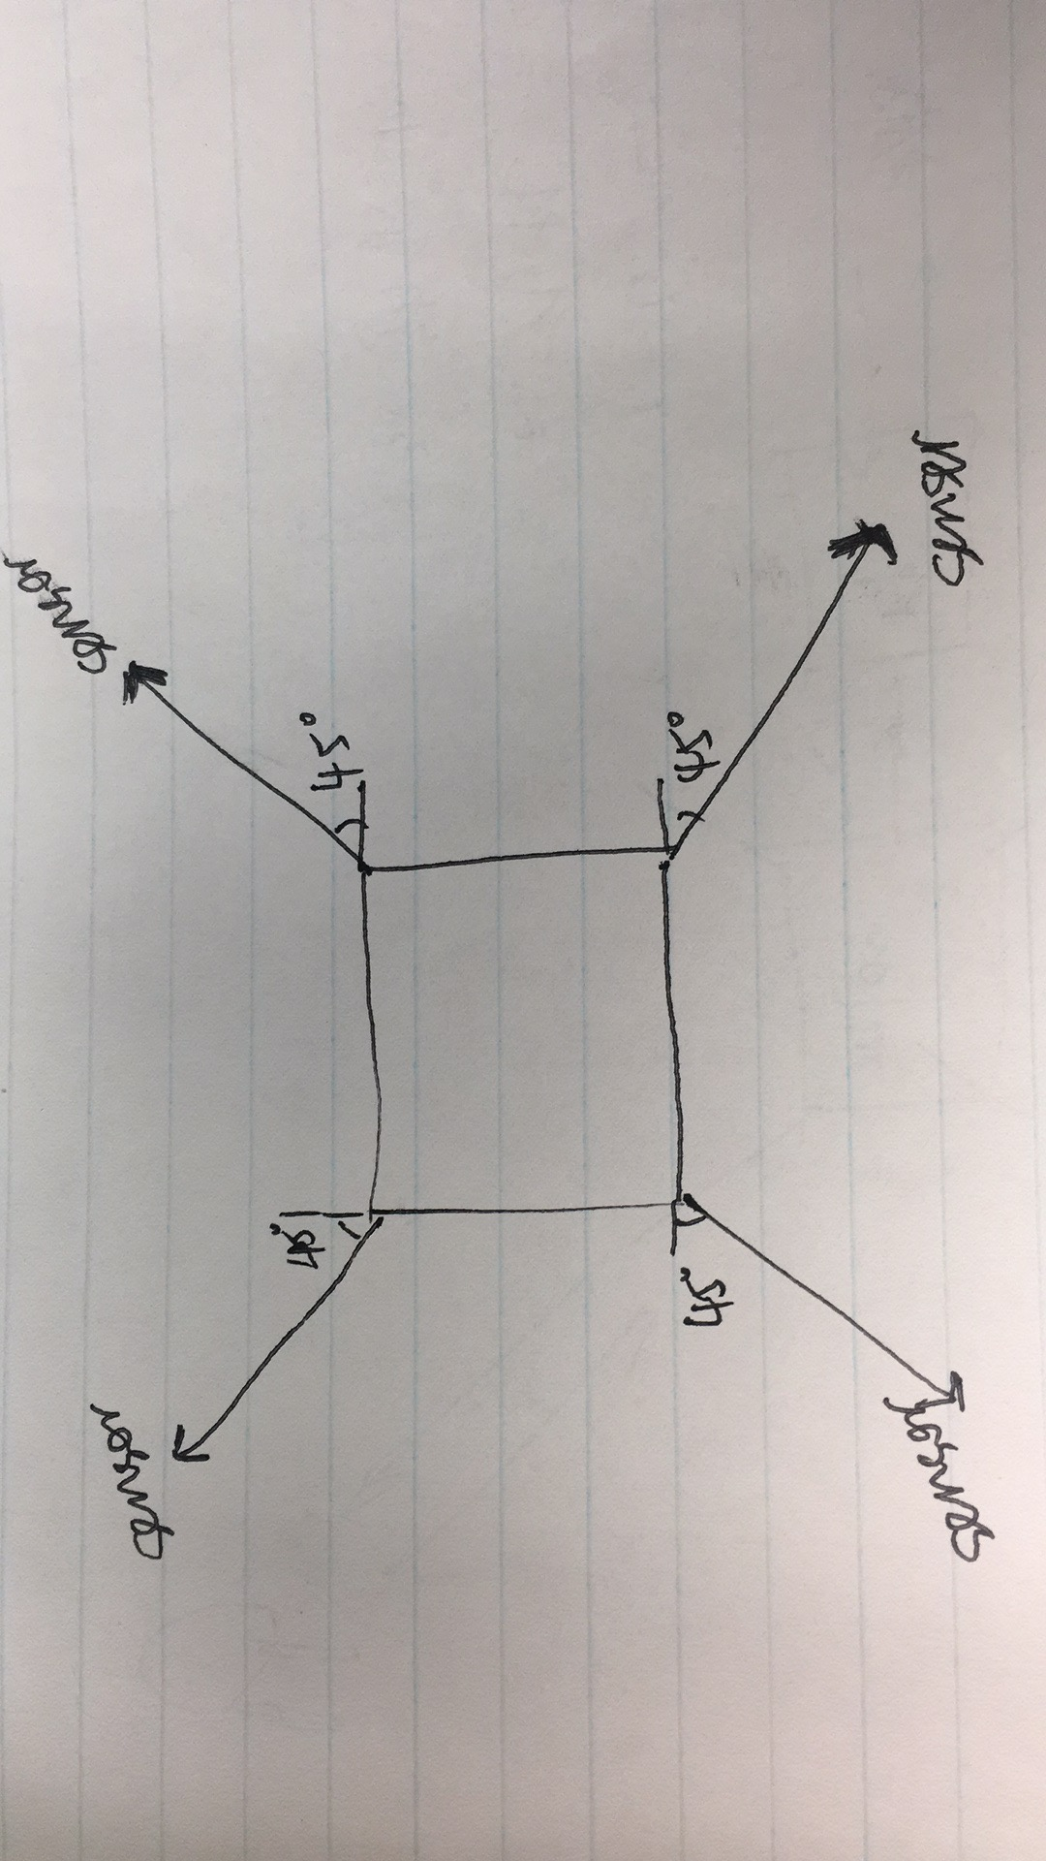

Video explanation:

IMG_0150 & IMG_0151:

Before the formal test, this is a pre-test aimed to test the guidance system. As you can see, the drone hovered when it is closed to the wall in some distance. The distance can be set in guidance assistant software.

IMG_0152:

With the guidance system, the drone can get its body position. In this video, when the drone moved to other direction manually, it can return to its original position. This function is very useful for our project.

IMG_0143 & IMG_2292:

The drone fly above the box. Due to the strong wind of the propeller, the drone may land to a wrong place. Theoretically, the drone can land or take off vertically. This problem appeared many time during the test.

IMG_0146:

It’s one of almost successful test. The drone landed in the right position. However, the box laid to one side. If the box vertically stand above group, the claw can grab it up.

IMG_0147:

This video mimic the process after the claw grab box. The drone flied to table. This process is easy to achieve.

IMG_0148:

This video test the power of wind generated from propeller. The box puts on the table without any support frame. As you can see, the wind blew the box so far away.

IMG_2291:

This video is one of the typical failed test. The claw didn’t get the box due to the wind. However, the drone get the right position. It is so hard to achieve the goal. The drone can only reach the whole goal step by step. There are two keys to achieve the goal: the drone flies to the right position, and the claw need to grab the box. But the claw has a low rate to grab and lift the box.

IMG_2297 & IMG_2305:

If the space is tiny, the drone cannot fly stably. It’s dangerous and easy to fail. In IMG_2300, the drone is not suitable to fly into a narrow space. The wind may lead to fail and danger.

IMG_2300 & IMG_2309 & IMG_2313 & IMG_2314 & IMG_2315: claw mission fail. The claw should update its effective sector.

IMG_2302:

This video shows the wired problem during indoor flying test. When the drone hovered in air, the compass has magnetic interface error sometimes.

IMG_2316: This is the only successful test during five-hours test.